## CHAPTER 13 CARBOXYLIC ACIDS

*Animaton 13.1: Addition of HCl to a carbonyl group*

*Source & Credit : Ch.imperial*

**IN THIS CHAPTER YOU WILL LEARN:**

1. How to name carboxylic acids and their derivatives.
2. The commercial method for the preparation of acetic acid.
3. The relationship between the structure of carboxyl group and its reactivity.
4. The effect of hydrogen bonding on the physical properties of carboxylic acids.
5. The ways of preparing four derivaties of carboxylic acids and the conversion of these derivatives back to carboxylic acids.
6. About amino acids and their significance.

### 13.1 INTRODUCTION

Organic compounds containing (- C - OH) as a functional group are called

carboxylic acids. The group which itself is made up of a carbonyl (- C - OH) group (> C = 0) and a hydroxyl group (-0H) is called a carboxyl group (Carb from carbonyl and oxyl from hydroxyl). Carboxylic acid may be an aliphatic

or an aromatic depending upon whether is attached to an alkyl (- C - OH) group (or a hydrogen atom) or an aryl group. Their general formulas are:

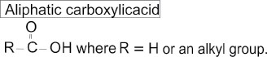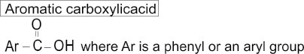

Carboxylic acids are further classified as mono, di, tri or poly carboxylic acids as they contain one, two, three or many carboxyl groups respectively in their molecules.

*Animaton 13.2: Carboxyl*

*Source & Credit : Phschool*

Aliphatic monocarboxylic acids



Aliphatic dicarboxylic acids

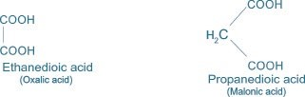

Aromatic monocarboxylic acid Aromatic dicarboxylic acid:

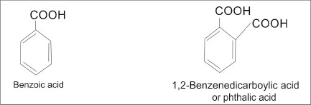

|  |
| --- |
| 2 3 |

In this chapter we will discuss, in some detail, the chemistry of monocarboxylic acids only.

### 13.2 NOMENCLATURE OF CARBOXYLIC ACIDS

The aliphatic monocarboxylic acids are commonly called fatty acids because higher members of this series such as palmitic acid (C15H31COOH), stearic acid (C17H35COOH), etc. are obtained by the hydrolysis of fats and oils. The aliphatic monocarboxylic acids may be given common names or IUPAC names.

#### 13.2.1 Common or Trivial names

The common names of carboxylic acids were derived from the source from which they are isolated. The irritation caused by an ant bite is due to formic acid (Latin word formica, ant). It was first isolated by the distillation of red ants. Similarly acetic acid was first isolated from vinegar and butyric acid was named after butyrum means butter.

#### 13.2.2 The IUPAC Nomenclature

The IUPAC names of saturated monocarboxylic acids are alkanoic acids. These are derived from the names of the alkanes containing the same number of carbon atoms as the acid. The ending “e” of the alkane name is dropped and suffix-oic acid is added. Thus acetic acid gets the name ethanoicaeid.

The position of substituents are indicated by Arabic numerals with the carboxyl group given number 1 as shown below:

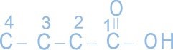

The common and IUPAC names of the some common monocarboxylic acids are given in the table below.

**Table(13.1) Common and IUPAC names of some common carboxylic acids.**

|  |  |  |
| --- | --- | --- |
| Structural Formula | Common Name | IUPAC Name |
| H COOH | Formic acid | Methanoic acid |
| CH3COOH | Acetic acid | Ethanoic acid |
| CH3 CH2 COOH | Propionic acid | Propanoic acid |
| CH3 CH2 CH2 COOH | Butyric acid | Butanoic acid |
| CH3 CHCOOCH    CH | Iso-Butyric acid | 2-Methylpropanoic acid |

3

### 13.3 GENERAL METHODS OF PREPARATION

A number of methods for the preparation of carboxylic acids have already been discussed in the previous chapters. However, they are recalled again with different examples. **1. From Primary Alcohols and Aldehydes**

Primary alcohols and aldehydes are readily oxidised to corresponding carboxylic acids by oxidising agents such as potassium dichromate in an acidic medium.

|  |
| --- |
| 4 5 |

*Animaton 13.5 : Undergo oxidation ource & Credit : Biologie.uni-hamburg.de*





Aldehydes are easily oxidised to corresponding carboxylic acids even by mild oxidizing agents such as Tollen’s Reagent (Ammoniacal silver nitrate).



#### 2. From Alkanenitriles

Compounds having a cyanide ( - C ≡ N) group are called nitriles. Hydrolysis of an alkanenitrile on boiling with mineral acids or alkalis yields corresponding carboxylic acid.

Alkanenitriles can be prepared by treating alkyl halide with alcoholic potassium cyanide.



It may be noted that acid produced has one carbon atom more than the original alkyl halide.

#### 3. From Grignard Reagent

Carboxylic acids can be prepared by the action of Grignard reagent with carbon dioxide. This reaction is either carried out by passing carbon dioxide through the ethereal solution of corresponding Grignard reagent or by adding Grignard reagent to crushed dry ice suspended in ether. The addition product on reaction with a mineral acid produces carboxylic acid.

|  |
| --- |
| *Animaton 13.6 : Nucleophilic substitution ource & Credit : Wikipedia.org*    6 7 |

*Animaton 13.7 : Grignard Reagent Attacking a Ketone ource & Credit : Benettonplay*

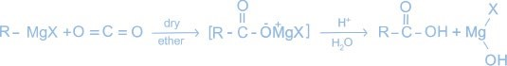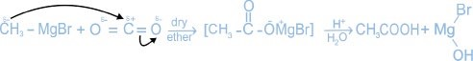

#### 4. By the Hydrolysis of Esters

The appropriate ester on boiling with concentrated sodium hydroxide yields sodium salt of the acid.This resulting salt when treated with dilute HC1 gives the free carboxylic acid.

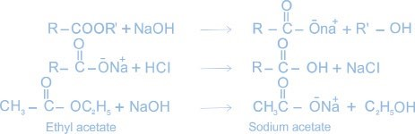



#### 5. By the Oxidative Cleavage of Alkenes

Alkenes when heated with alkaline KMnO4 are cleaved at the double bond to form carboxylic acids.

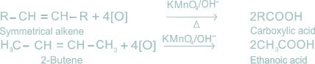

### 13.4 PHYSICAL CHARACTERISTICS

#### (i) Smell

The first three aliphatic acids i.e. formic acid, acetic acid and propionic acid are colourless liquids and have pungent smell. The next three acids C4 to C6 are colourless liquids with somewhat unpleasant smell. **(ii) Solubility**

Among the aliphatic acids, the first four members are very soluble in water due to hydrogen bonding.



#### (iii) Boiling Point

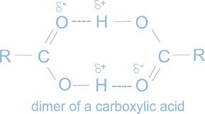The boiling points of carboxylic acids are relatively high due to intermolecular hydrogen bonding. The molecular mass determination in non-polar solvent like benzene shows that Carboxylic acids exist as cyclic dimers.

##### Boiling Points

HCOOH CH3COOH C2H5COOH

373K(100°C) 391K(118°C) 424K(141°C)

##### Melting Points

The melting points of carboxylic acids increase irregularly with the increase in molecular mass. It has been observed that the melting points of carboxylic acids containing even number of carbon atoms are higher than the next lower and higher members containing odd number of carbon atoms e.g.,

8 9

### CH CH COOH, CH CH CH COOH, CH CH CH CH COOH3 2 3 2 2 3 2 2 2

(3 carbon) (4 carbon) (5 carbon)

**Melting**

**points** 251K(-22°C) 267 K (-6°C) 237 K (-36°C)

#### 13.5 REACTIVITY OF CARBOXYL GROUP ( C OH)

The carboxyl group displays the chemistry of both the carbonyl and the hydroxyl groups. In most reactions of carboxylic acids the carboxyl group is retained however, the reactivity of these molecules is a consequence of the presence of the carbonyl group.

#### 13.6 Reactions of Carboxylic Acids

Carboxylic acids undergo the following type of reactions.

1. The reactions in which hydrogen atom of the carboxyl group is involved (salt formation).
2. The reactions in which OH group is replaced by another group.
3. The reactions involving carboxyl group as a whole.

##### (a) Reactions Involving H Atom of the Carboxyl Group

Carboxylic acids are weaker acids than mineral acids. They furnish H+ when dissolved in water.

10

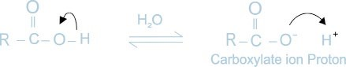

In the presence of water (H2O), the proton breaks away as H3O+ ion.

**1. Reactions with Bases**

Carboxylic acids react with bases (NaOH, KOH) to form salts

### CH COOH + NaOH3 → CH COONa + H O3 2

**2. Reactions with Carbonates and Bicarbonates**

Carboxylic acids decompose carbonates and bicarbonates evolving carbon dioxide gas with effervescence.

2CH COOH+Na CO3 2 3 → 2CH COO Na +CO +H O3 - + 2 2

### CH COOH + NaHCO3 3 → CH COO Na + CO + H O3 − + 2 2

**3. Reactions with Metals**

Carboxylic acids react with active metals (Na, K, Ca, Mg etc) to form their salts with the evolution of hydrogen gas.

2CH COOH+2Na3 →2CH COO Na +CO +H3 - + 2 2

#### (b) Reactions Involving the OH Group of Carboxylic Acids

The carboxylic acid contains C OH functional group, and like the carbonyl group of aldehydes and ketones, is susceptible to attack by a nucleophile. The addition of a nucleophile to the carboxyl group is always followed by the displacement of the OH group by some other group, producing a carboxylic acid derivative. The OH group can thus be replaced by X, OR and NH2 to form halides, esters and amides,respectively.

**1 . Reactions with PCI5 and SOCI2**

1. CH COOH + PCl3 5 → CH COCl + POCl +HCl3 3
2. CH COOH + SOCl3 2 → CH COCl + SO + HCl3 2

11

#### Mechanism



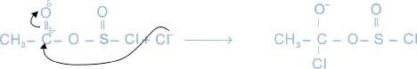

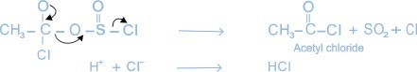

**2. Formation of an Ester**

When carboxylic acids are heated with alcohols in the presence of concentrated H2SO4, esters are formed.

### CH COOH + C H OH3 2 5  H SO2 4 CH COOC H + H O3 2 5 2

*Animaton 13.8 : Ester formation ource & Credit : Dynamicscience*

12

#### Mechanism

The various steps of the above reactions are as follows:

**(i) Protonation of Carboxylic Acid**



**(**

**iii) Hydrogen Ion Transfer**

**(**

**ii) Attack of CH**

**3**

**CH**

**2**

**OH**

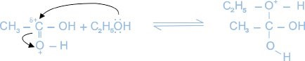

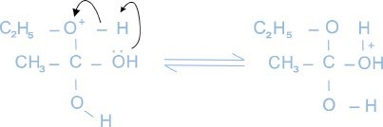

**(iv) Elimination of Water and H+**

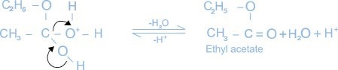

Esters have fruity smell and are used as artificial flavours. Flavours of some estersare listed in the table.

13

|  |  |
| --- | --- |
| **Ester** | **Flavour** |
| Amylacetate  Isobutyl formate  Benzylacetate  Ethyl butyrate  Amyl butyrate  Octyl acetate | Banana  Raspberry Jasmine  Pineapple  Apricot  Orange |

**3.Formation of Amide (Reaction with ammonia)**

Carboxylic acids react with ammonia to form ammonium salts which on heating produce acid amides.

### (i) CH COOH + NH3 3 → CH COONH3 4

#### CH COO N H- + Heat CH CONH + H O

3 4 → 3 2 2

##### Mechanism

(ii)

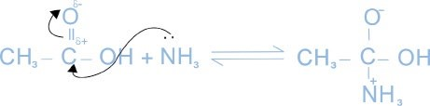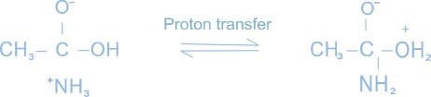

14

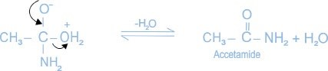

(

iii

)

**4. Formation of Acid Anhydride**

Carboxylic acids are dehydrated on heating strongly in the presence of phosphorus pentoxide.



**(**

**c) Reactions Involving Carboxyl Group (**

**C**

**OH)**

**i. Partial Reduction to Alcohols**

Carboxylic acids on reaction with lithium aluminium hydride (LiAIH4) are reduced to alcohols.



**ii) Complete Reduction to Alkanes**

Carboxylic acids on reduction with HI and red phosphorus give alkanes.

CH COOH + 6HI3 →P CH3 CH + 2H O + 3I3 2 2

##### 13.7 ACETIC ACID

It is the most important carboxylic acid. Its dilute solution is known as vinegar. Acetic acid can be prepared by any of the general methods described earlier.

15

###### 13.7.1 Laboratory Methods

1. By the Oxidation of Ethyl Alcohol or Acetaldehyde

When ethyl alcohol is oxidised with K2Cr2O7 and dilute H2SO4, acetic acid is produced.

#### CH3 CH OH + O2 [ ]→K Cr OH SO2 2 72 4 CH CHO3 →[ ]O CH COOH3

##### 2. By the Hydrolysis of Methyl Cyanide

Ethanenitrile on hydrolysis with dilute HCI, gives acetic acid through acetamide.



##### 13.7.2 Manufacture of Acetic Acid

###### 1 . From Acetylene

Acetylene is treated with 20% H2SO4 and 1.0% HgSO4 at 80°C to give ethanal (acetaldehyde) which is then oxidised using V2O5 to give acetic acid.



**2.** Acetic acid is also prepared commercially by the oxidation of ethyl alcohol.Ethyl alcohol can be commercially prepared from molasses by a process called fermentation.It is oxidized by potassium dichromate in the presence of conc. sulphuric acid to give acetaldehyde which is further oxidized under the same conditions to give acetic acid.

16

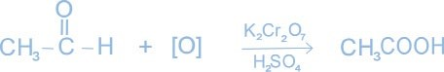

##### 13.7.3 Physical Characteristics

Acetic acid is a colourless liquid with a boiling point 118°C. It has a strong vinegar odour and sour taste. The pure acid freezes to an ice like solid at 17 °C, therefore, it is called glacial acetic acid. It is miscible with water, alcoholand ether in all proportions.

##### 13.7.4 Reactions of Acetic Acid

Chemical reactions of acetic acid have already been discussed in the general properties of the carboxylic acids.

##### 13.7.5 Uses of Acetic Acid

Acetic acid is used:

i) as a coagulant for latex in rubber industry. ii) in the manufacture of plastics (polyvinyl acetate) rayon (cellulose acetate) and silk.

1. in medicine as a local irritant.
2. as a solvent in the laboratory for carrying out reactions.v) in the manufacture of pickles.

vi) in the manufacture of many organic compounds like acetone, acetates

and esters.

##### 13.8 AMINO ACIDS

Amino acids are organic compounds containing both amino and carboxyl groups. They are represented by the general formula:

17

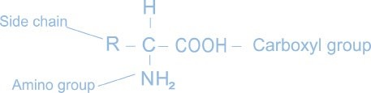

R is different for different amino acids. The amino group may be present at any carbon atom other than that of the carboxyl group ( COOH). They are referred to as α, β, γ depending upon whether the amino group is present on the α, β, or γ carbon atom relative to the carboxyl group. Almost all the naturally occurring amino acids are α amino acids. These amino acids are very important because they are the building blocks of proteins. Proteins are very important for us.

The amino acids which contain two carboxyl groups are called acidic amino acids while those containing two amino groups are called basic amino acids. For example, glutamic acid and aspartic acid are acidic amino acids while lysine is a basic amino acid.

About twenty amino acids have been identified as the constituents of most of the animal and plant proteins.

###### 13.8.1 Essential and Non-essential Amino Acids

Out of twenty amino acids which are required for protein synthesis, the human body can synthesize only ten. The amino acids which body can synthesize are called non-essential amino acids. The remaining ten amino acids which the body is not able to synthesize are called essential amino acids.

The essential amino acids must be supplied to our bodies through our diet because they are required for proper health and growth. The deficiency of essential amino acids may cause diseases. **13.8.2 Nomenclature of Amino Acids**

Although amino acids can be named according to IUPAC system, they are generally known by their trivial names. These trivial names usually reflect the origin or an obvious property of the compound.

Glycine, for example is so named, because it has a sweet taste (Greek glykys - sweet) and the tryosine was first isolated from cheese (from Greek tryos-cheese). For the sake of simplicity, each amino acid has been given an abbreviation w’hich generally consists of the first three letters of the common name.

18

For example, the simplest amino acid is glycine H2NCH2 COOH. It may be abbreviated as Gly. Similarly, alanine CH3 CH COOH may be represented as Ala.

NH2

Names, structural formulae and other features of some amino acids are given in Table 13.2.

Table 13.2 Names, structural formulae and other features of amino acids

|  |  |  |  |  |
| --- | --- | --- | --- | --- |
| Name Nature Abbreviation | | | | Structural formula |
| 1 | Glycine | Neutral | Gly | CH2 COOH  NH2 |
| 2 | Alanine | Neutral | Ala | CH3 CH COOH  NH2 |
| 3 | Valine | Neutral | Val | CH3 CH CH COOH  CH3 NH2 |
| 4 | Proline | Neutral | Pro | H2C CH2  H2C CHCOOH  NH |
| 5 | Aspartic acid | Acidic | Asp | HOOC CH2  CH COOH  NH2 |
| 6 | Glutamic acid | Acidic | Gla | HOOC CH2 CH2 CH COOH  NH2 |
| 7 | Lysine | Basic | Lys | CH2 (CH2)3 CH COOH  NH2 NH2 |
| 8 | Histidine | Basic | His | CH = C CH2 CH COOH  N NH NH2  CH |

###### 13.8.3 Structure of Amino Acids

The amino acids exist as dipolar ion called Zwitter ion. It has positive as well as negative ends within the same molecule. In the formation of Zwitter ion, the proton goes from the carboxyl group to amino group. The Zwitter ionic structure of an amino acid may be written as:

19

*Animaton 13.9 : Formation of the peptide bond ource & Credit : Researchpeptides*

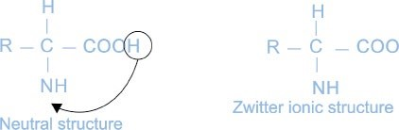

The dipolar structure is also called internal salt. All α - amino acids exist largely in dipolar ionic forms.

###### 13.8.4 Acidic and Basic Characters of Amino Acids

On the basis of dipolar ion structure, the acidic and basic reactions of amino acids may be represented as :

1. When an acid is added to an amino acid the carboxylate ion accepts the proton and, therefore, the basic character is due to this group.

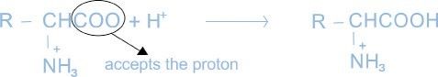

1. When an alkali is added to an amino acid, NH3 group releases the proton and therefore the acidic character is due to this group.

20



###### 13.8.5 Synthesis of Amino Acids

Amino acids can be synthesized by the following reactions.

1. By the reaction of α - bromoacid with ammonia.





2. The Strecker Synthesis

When hydrogen cyanide is added to an aldehyde in the presence of ammonia, α - amino acid is obtained.



α - amino nitdle upon acidic hydrolysis yields an α - amino acid:

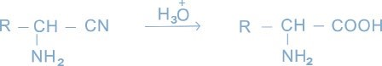

###### 13.8.6 Reactions of Amino Acids

Amino acids undergo many chemical reactions characteristics of either amino group or carboxyl group.

**1. Esterification**

Amino acids form aminoester when treated with an alcohol in the presence of catalytic amount of a strong acid.

21



2. Reaction with Nitrous Acid

Amino acids react with nitrous acid to produce α - hydroxy carboxylic acid and nitrogen gas.



###### 13.8.7 Test of Amino Acids

Ninhydrin Test

Ninhydrin reacts with amino acid to form an intensely coloured bluish violet product. The ninhydrin reaction is also widely used to “visualize’’ amino acids separated by paper chromatography.

###### 13.8.8 Peptidos and Proteins

Peptides are the compounds formed by the condensation of two or more same or different a-amino acids. The condensation occurs between amino acids with the elimination of water. In this case, the carboxyl group of one amino acid and amino group of another amino acid gets condensed with elimination of water. The resulting CO NH linkage is called a peptide linkage. The formation of peptide is shown below:

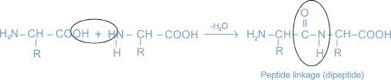

If a large number of amino acids (hundreds to thousands) are joined by peptide bonds, the resulting polymide is called a polypeptide.

22

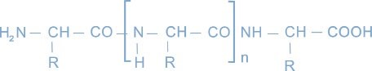

Depending upon the number of amino acids per molecule, the peptides are dipeptides, tripeptides, polypeptides, etc. The formation of peptide bonds can continue until a molecule containing several hundred thousand amino acids is formed. Such a molecule is called polypeptide or protein. By convention a peptide having molecular mass upto 10,000 is called a polypeptide while a peptide having a molecular mass more than 10,000 is called a protein.

##### KEYPOINTS

1. Organic compounds containing carboxyl group ( C OH) are called carboxylic acids. There are two classes of carboxylic acids i.e., aliphatic and aromatic carboxylic acids. Aliphatic carboxylic acids are also called fatty acids
2. Carboxylic acids can be produced by the oxidation of alcohols and aldehydes and by the hydrolysis of nitriles.
3. Lower members of the series are water soluble and have pungent smell. Solubility decreases with the increase in molecular mass.
4. Carboxylic acids have higher boiling points than the corresponding alcohols. Boiling point increases with the increase in the molar mass.
5. Acid chlorides, acid amides, esters and acid anhydrides are called derivatives of carboxylic acids.
6. Acetic acid is synthesized on commercial scale from acetylene.
7. Carboxylic acids containing amino group in their molecules are called amino acids. They are classified as neutral, basic and acidic amino acids.
8. Amino acids join together to produce peptides. A polypeptide has a molecular mass upto 10,000 whereas the molecular mass of protein is greater than 10,000.

23

###### EXERCISE

**Q. 1 Fill in the blanks.**

1. Formula of malonic acid is___________________.
2. Methyl nitrile upon acidic hydrolysis produces_______________ . (iii) Melting points of carboxylic acids containing even number of carbon atoms are________________ than the next lower and higher members containing odd number of carbon atoms.
3. Acetic acid on heating with_____________produces acetic anhydride.
4. Acid chloride and acid anhydride are called_______________ of acid.
5. Pure acetic acid is called ________________ .
6. Fox mula of alanine is_____________________.
7. Proline is a__________________ amino acid.
8. A peptide having a molecular mass more than 10000 is called_______________. **Q. 2 Indicate True and False.**
9. Acetic acid exists as a dimer in benzene.
10. First three aliphatic acids have fruity smells.
11. Carboxylic acids on reduction with LiAlH4 produce alkenes.
12. Acetic acid on dehydration produces CO and H2.
13. Sodium formate on heating with soda lime produces NaHCO3 and hydrogen.
14. Amino acids exist as Zwitter ion.
15. Histidine is an acidic amino acid.
16. A peptide having molecular mass upto 10000 is called protein.
17. Phthalic acid is a monocarboxylic acid.
18. Formula of glycine is CH2COOH.

**Q. 3 Multiple choice questions. Encircle the correct answer.**

(i) Acetic acid is manufactured by

(a) distillation (b) fermentation (c) ozonolysis (d) esterification

(ii) A carboxylic acid contains

(a) a hydroxyl group (b) a carboxyl group

(c) a hydroxyl and carboxyl group (d) a carboxyl and an aldehydic group

24

(iii) Which acid is used in the manufacture of synthetic fibre

(a) formic acid (b) oxalic acid (c) carbonic acid (d) acetic acid

1. Which following derivative can not be prepared directly from acetic acid.(a) acetamide (b) acetyl chloride (c) acetic anyhdride (d) ethyl acetate
2. Which reagent is used to reduce a carboxylic group to an alcohol.

(a) H2/Ni (b) H2/Pt (c) NaBH4 (d) LiAlH4

(vi) The solution of which acid is used for seasoning of food.

(a) formic acid (b) acetic acid (c) benzoic acid d) butanoic acid

1. Organic compounds X and Y react together to form organic compound Z. What type of compounds can X, Y and Z be?

X Y Z

* 1. alcohol ester acid
  2. acid ester alcohol
  3. ester alcohol acid
  4. alcohol acid ester

1. An aqueous solution of an organic compound reacts with sodium carbonate to produce carbon dioxide gas. Which one of the following could be the organic compound.

(a) CH2 = CH CH3 (b) CH3 CHO (c) CH3COOC2H5 (d) CH3 CH2 COOH

(ix) Which of the following is not a fatty acid?

(a) propanoic acid (b) acetic acid

(c) phthalic acid (d) butanoic acid

(x) Acetamide is prepared by

(a) heating ammonium acetate (b) heating methyl cyanide

(c) heating ethyl acetate (d) the hydrolysis of methyl cyanide

25

**Q. 4** Write down the structural formulae of the followings

(i) Valeric acid (ii) Propionic acid (iii) Oxalic acid (iv) Benzoic acid (v) Acetic anhydride (vi) Acetyl chloride

**Q. 5** Write down the names of the following compounds by IUPAC system.

(i) 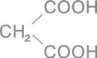 (ii) 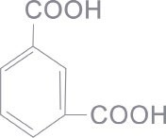

(iii) 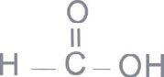 (iv) 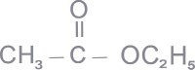

(v) CH2COOH (vi) HCOOC3H7  NH2

**Q. 6 (a)** How is acetic acid manufactured? What is glacial acetic acid?

**(b)** How would you convert acetic acid into the following compounds?

(i) Methane (ii) Acetyl chloride (iii) Acetamide

(iv) Acetic anhydride

**Q. 7 (a)** What are fatty acids ?

**(b)** What is vinegar? Describe how is vinegar prepared from ethanol?

**Q. 8** How would you carry out the following conversions?

(i) Acetic acid into acetamide (ii) Acetic acid into acetone

**Q. 9** Write down the mechanisms of the following reactions.

(i) between acetic acid and ethanol (ii) between acetic acid and ammonia

(iii) between acetic acid and thionyl chloride

26

**Q. 10** What happens when the following compounds are heated.

(i) Calcium acetate (ii) Sodium formate and soda lime

(iii) Ammonium acetate

**Q. 11** What are amino acids? Explain their different types with one example in each case.

**Q. 12** Write a short note on acidic and basic characters of an amino acid.

**Q. 13** What is a peptide bond? Write down the formula of a dipeptide.

**Q. 14** What are zwitter ions?

**Q. 15** What are a amino acids, proteins and peptides? How are they related?

**Q. 16** Study the facts given in (a), (b) and (c) below and then answer questions which follow.

1. A is an organic compound made up of C, H and O. It has a vapour density 15.[Hint: Molecular mass = 2 x vapour density].
2. On reduction A gives a compound ‘X’ which has the following properties.
3. X is a colourless liquid miscibie with water.
4. X is neutral to litmus.
5. When X is warmed with a few drops of conc. H2SO4 followed by a little salicylic acid a characteristic smell is produced.

**(c)** When X is subjected to strong oxidation, it gives compound B, which has the following properties.

1. B is a pungent smelling mobile liquid.
2. It is miscible with water, alcohol or ether.
3. It is corrosive and produces blisters on contact with skin.
4. B can be obtained by passing the vapours of A with air over platinum black catalyst.
5. B liberates H, with sodium.
6. It givesCO2 with NaHCO3.
7. What is the molecular mass of A?
8. Identify A, X and B.
9. Give five appropriate reactions to confirm the identities of A, X and B.
10. State one large-scale use of either A, X or B.

27

## CHAPTER 14 MACROMOLECULES

|  |
| --- |
| **In This Chapter You Will Learn** |
| 1. The concepts of polymerization and macromolecules. 2. Types of polymerization and products of these polymerizations e.g., polyvinyl chloride, polystyrene, polyvinyl acetate, polyamides, polyester and epoxy resins. 3. About life molecules, for example, carbohydrates, lipids, proteins, enzymes and nucleic acids. |

### 14.1 INTRODUCTION

Acceptance of the macromolecular hypothesis came about in 1920’s largely because of the efforts of Staudinger. He proposed long chain formulas for polystyrene, rubber and polyoxymethylene. Macromolecules or polymers are described as large molecules built up from small repeating units called monomers.

The development of the process of polymerization is, perhaps, one of the most significant things chemists have done, where it has had the major effect on every day life. The world would be a totally different place without artificial fibres, plastics, etc. One of the most significant changes has been the gradual replacement of natural materials such as wood and cotton with man made synthetic polymers. For better or worse we are living in a “plastic” society.

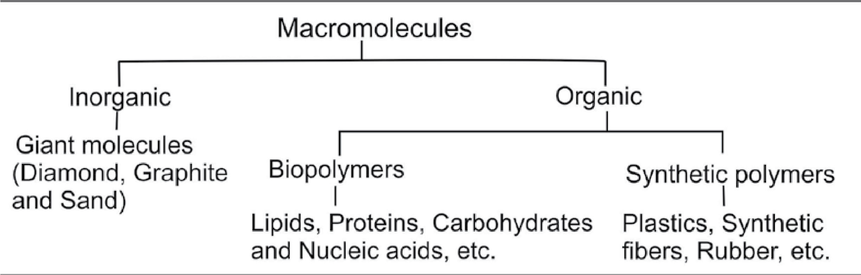

*Fig. 14.1 Classification of macromolecules*

The word polymer is derived from Greek, polymeans ‘many’ and mer means ’parts’. Macromolecules can be classified into the following types, Fig 14.1.

### 14.2 STRUCTURE OF POLYMERS

A polymer is a large molecule build up by the repetition of small and simple chemical units known as monomers. In some cases the repetition is linear while in others, it is branched or interconnected to form three dimensional network Fig 14.2.

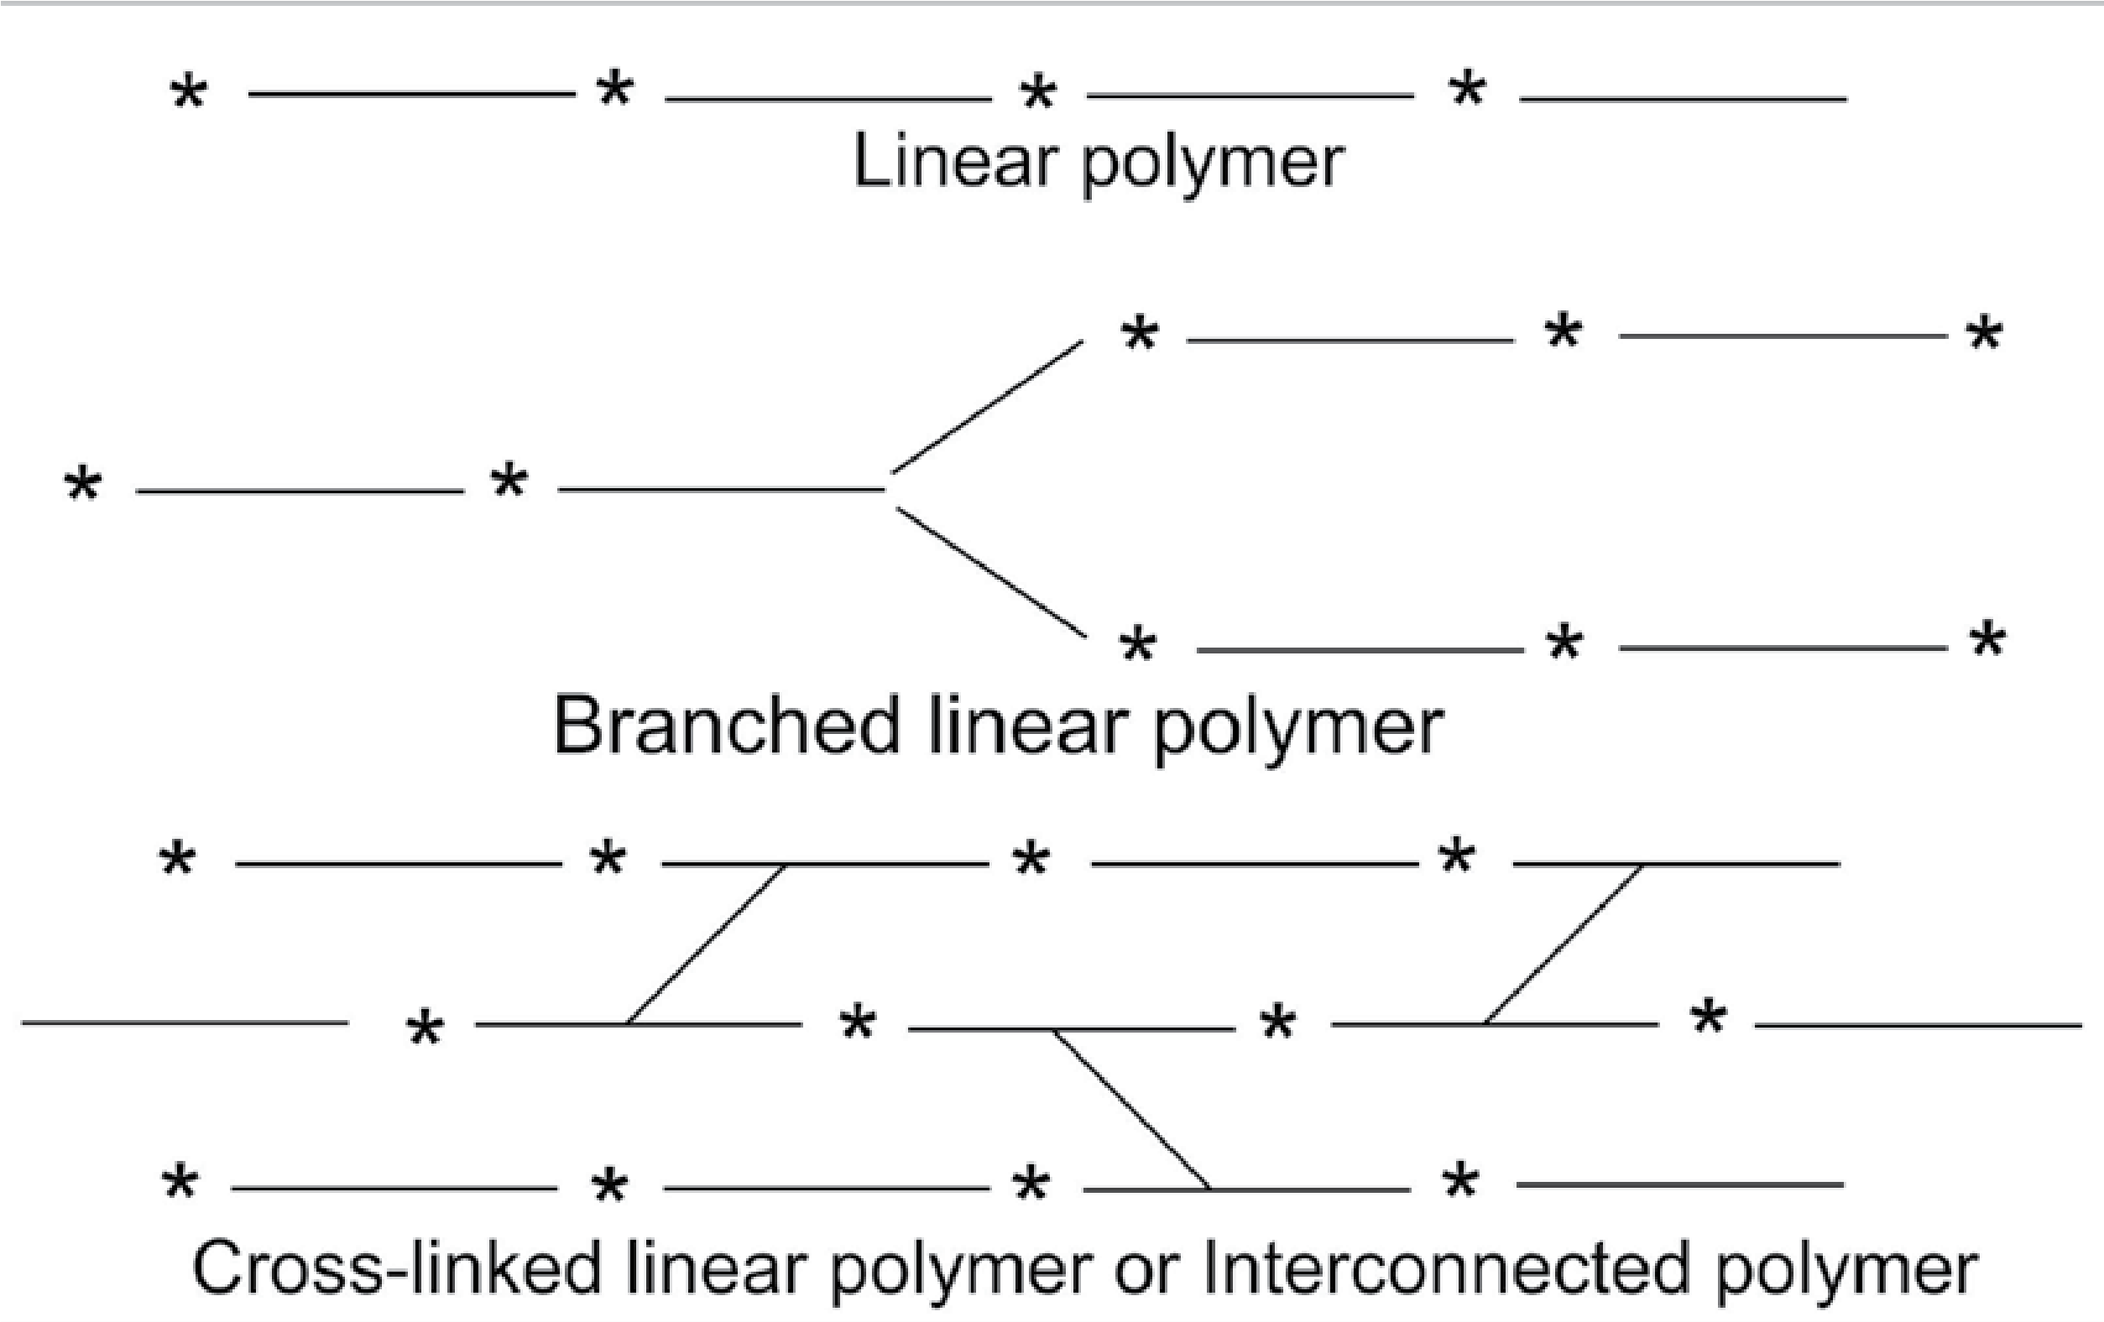

*Fig. 14.2 Three ways of polymerization*

|  |
| --- |
| 2 3 |

The length of the polymer chain is specialized by the number of repeating units in the chain known as the degree of polymerization (DP), for example, in linear polythene.



The repeating unit is where n is a large number.

The molecular mass of the polymer is the product of the molecular mass of the repeating unit and the DP For example, polyvinyl chloride, a polymer of

DP 1000, has a molecular mass

Mol. mass = Mol. mass of the repeat unit x DP

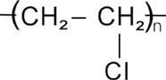 = 63.5 x 1000 = 63500

Most high molecular mass polymers are useful for making plastics, rubbers or fibres, etc. and have molecular masses between 10,000 to 1,000, 000. The properties of polymeric materials vary widely depending upon the chemical composition and structure of the macromolecule.

### 14.3 TYPES OF POLYMERS

The polymers formed are of the following types:

#### 1) Homopolymer

A homopolymer is formed by the polymerization of a single type of monomer. For example, the polymerization of vinyI acetate.

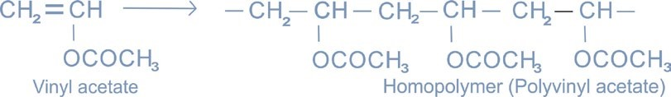

#### 2) Copolymer

A copolymer is formed by the polymerization of two monomers together, e.g; vinyl acetate reacts with butyl maleate to give a copolymer.

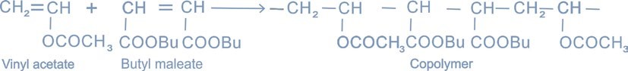

#### 3) Terpolymer

In terpolymer three different monomers are polymerized and the polymerization reaction is carefully controlled. For example, combination of butyl acrylate, methacrylate and acrylic acid monomers gives a highly tough polymer which serves as a weather-resistant paint. Based on the thermal properties of polymers, they can be divided into two types.

#### i) Thermoplastic Polymer

A thermoplastic polymer is one which can be softened repeatedly when heated and hardened when cooled with a little change in properties. For example; PVC pipes, plastic toys, etc.

#### ii) Thermosetting Polymer

The polymers which become hard on heating and cannot be softened again are called thermosetting polymers. A thermosetting polymer, on heating, decomposes instead of melting. For example, synthetic varnish, epoxy resins, etc.

### 14.4 POLYMERIZATION PROCESS

In 1929, W.H. Carothers suggested a classification of the polymerization process into two types depending upon the way the polymers are formed.

1. Addition polymerization 2. Condensation polymerization

#### 1) Addition Polymerization

|  |
| --- |
| 4 5 |

It is a free-radical addition reaction which involves initiation, propagation and termination steps. For example, polymerization of styrene. Addition of polymerization is catalyzed by thermal or photochemical decomposition of organic peroxides to give free radicals.

**Initiation**

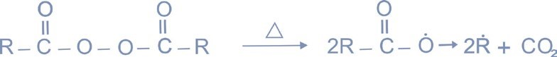

**Propagation**

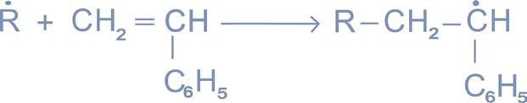

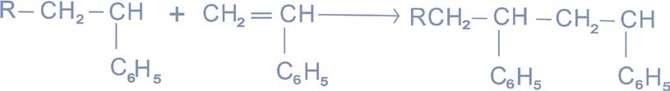



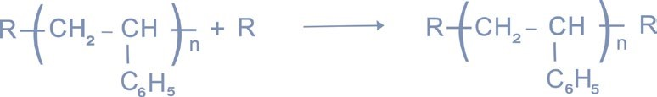**.**

##### 2. Condensation Polymerization

This type of polymerization results from the mutual reaction of two functional groups. The reaction usually involves the removal of a water molecule or a methanol molecule. It takes place at both ends of the growing chain. For example; dicarboxylic acids or esters combine with diols to get the desired polymer like nylon and polyester fibre. Such polymerizations are generally ionic in nature.

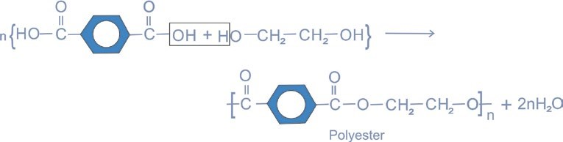

### 14.5 BRIEF DESCRIPTION OF SYNTHETIC POLYMERS

#### 1. Polyvinyl Chloride (PVC)

It is an addition polymer obtained by polymerizing vinyl chloride at 52°C and 9 atmospheric pressure.

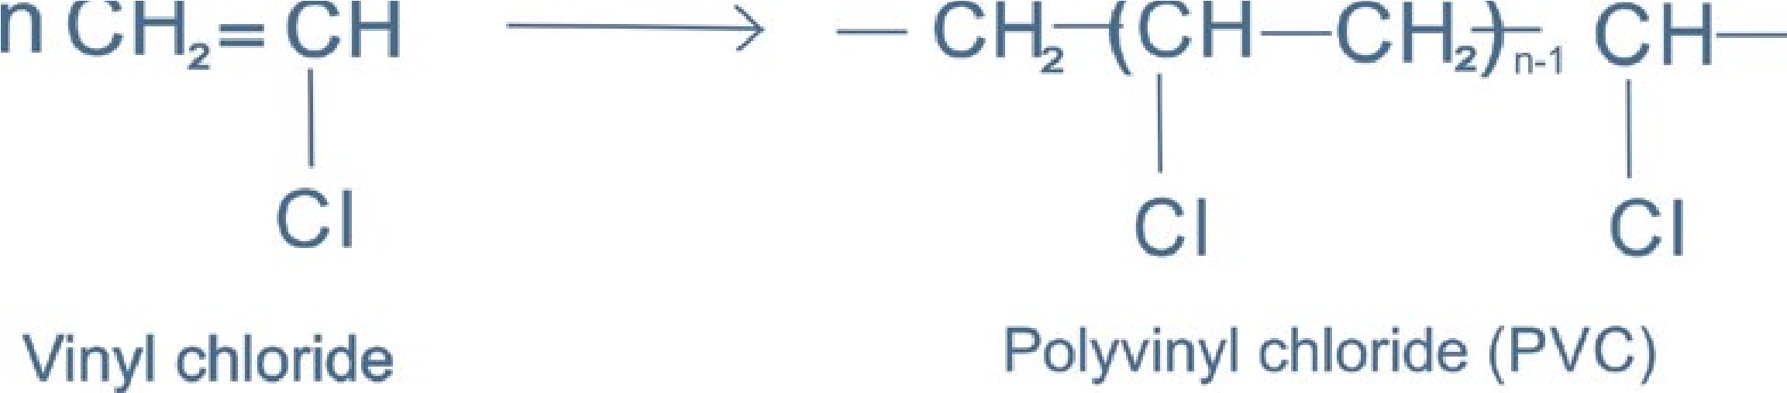

Addition of a plasticizer improves the flexibility of the polymer.It is widely used in floor coverings, in pipes, in gramophone recorders, etc.

#### 2) Polystyrene

It is also an addition polymer and is obtained by the polymerization of styrene in the presence of a catalyst.

|  |
| --- |
| 6 7 |

Polystyrene is used in the manufacture of food containers, cosmetic bottles, toys and packing material, etc.

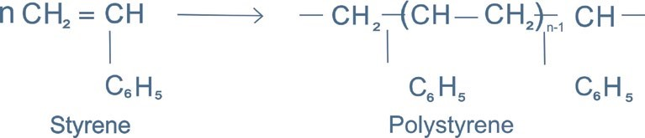

##### 3. Polyvinyl Acetate (PVA)

PVA is a colourless, non-toxic resin. It is supplied in a number of grades differing in the degree of polymerization.The resin has a characteristics odour. It is mostly used as an adhesive material and as a binder for emulsion paints.

##### 4. Acrylic Resins

These are closely related to the vinyl resins. The most important monomers of acrylic resins are methylmethacrylate, acrylic acid and butyl acrylate. The acrylic fibres are based largely on acrylonitrile.Acrylic resins are used in the manufacture of plastics, paints for car industry and water based weather resistant paints.

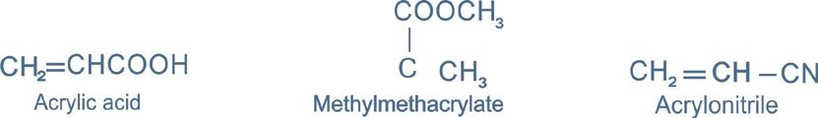

##### 5. Polyester Resins

Polyester resins are the product of the reaction of an alcohol (ethane 1, 2 diol) and aromatic bi-functional acids (benzene 1,4 dicarboxylic acid). This product has a large number of uses in clothing. Polyester is often blended with cotton or wool for summer and winter clothing. Polyester resins are also used for making water tanks, etc. (For a chemical equation please see under condensation polymerization).

#### 6) Polyamide Resins

These resins are formed by the condensation of polyamines with aliphatic dicarboxylic acids.One of the most famous condensation polymers discovered is Nylon.

The word Nylon has been accepted as a generic name for synthetic polyamides. Nylon 6, 6 is the most important polyamide. It is obtained by heating adipic acid (hexanedioic acid) with hexamethylene diamine. Nylon 6,6 derives its name from its starting materials adipic acid and hexamethylene diamine,both of which have six carbon atoms. Nylon is mainly used as a textile fibre. It has a combination of high strength, elasticity, toughness and abrasion resistance.

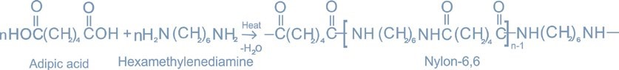

##### 7. Epoxy Resins

The epoxy resins are fundamentally polyethers but retain their name on the basis of their starting materials and the presence of epoxide group in the polymer.The epoxy resin is made by condensing epichlorohydrin with diphenylol propane.

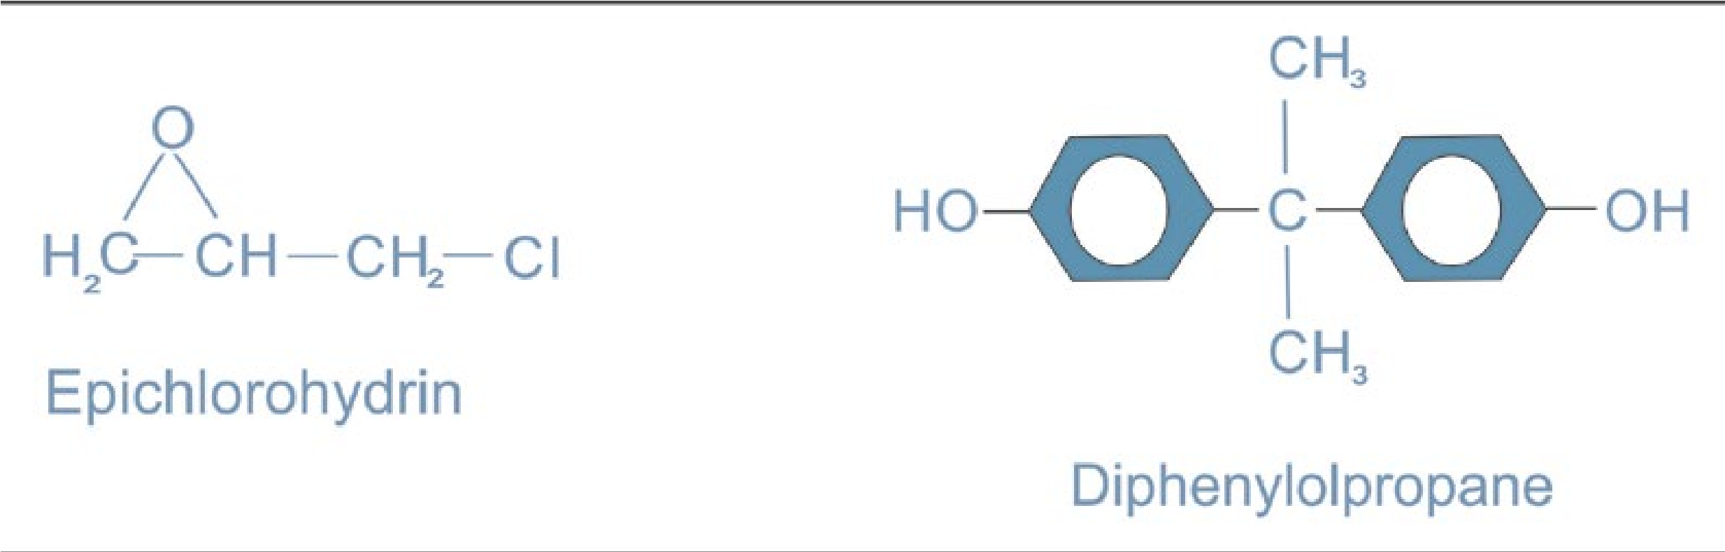

8 9

The major use of epoxy resins is in coating materials which give toughness, flexibility, adhesion and chemical resistance. Industrial materials, thermal power stations, packing materials are coated with epoxy paints. Dams, bridges, floors, etc. are painted with epoxy resins.

### 14.6 BIOPOLYMERS

Most biologically important substances are organic compounds built up from skeleton of carbon atoms. Many of them are very large molecules and most of these are polymers. The four major classes of organic compounds in living cells are carbohydrates, lipids, proteins and nucleic acids.

#### 14.6.1 Carbohydrates

The term carbohydrate is applied to a large number of relatively heterogeneous compounds. They are the most abundant biomolecules on earth. The name carbohydrate (hydrate of carbon) is derived from the fact that the first compound of this group which was studied had an empirical formula Cx (H2O)y . They are commonly called ‘sugars’ and are ‘polyhydroxy compounds’ of aldelydes and ketones.

#### 14.6.2 Classification of Carbohydrates

The commonly described classification is given below.

##### 1. Monosaccharides

These are simple sugars which cannot be hydrolyzed. They have an empirical formula (CH2O)n where n = 3 or some large number. Monosaccharides are either aldoses (aldehydic group) or ketoses (ketonic group). Common examples are glyceraldehyde, glucose, fructose, etc.

10

Sugars with five carbon atoms (pentoses) or six carbon atoms (hexoses) are more stable as cyclic structures than as open chain structures. Glucose and fructose are very common examples of hexoses, both of which have molecular formula, C6H12O6.

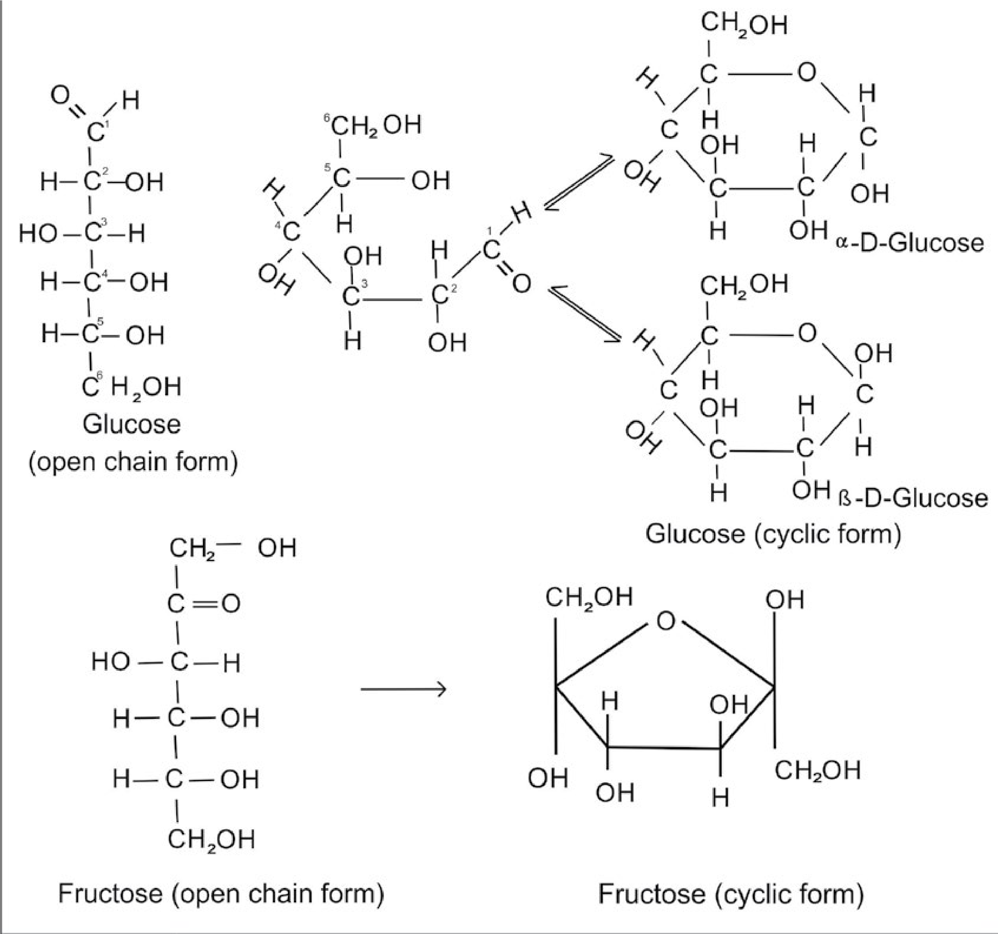

11

Glucose also called dextrose, grape sugar or blood sugar, occurs natuarlly in both combined and free states. In the free state, it is present in most sweet fruits and in honey. Small quantities of glucose are also present in human blood and urine. In the combined state it forms a major component of many disaccharides and polysaccharides.It is the source of energy in our body. Fructose is also found in combined and free states.It is used as a sweetening agent in confectionery and as a substitute of cane sugar. Other examples of monosaccarides are galactose and mannose.

##### 2. Disaccharides or Oligosaccharides

The oligosaccharides are formed when two to nine monosaccharide units combine by the loss of water molecules. This results in the formation of a glycosidic linkage. For example; sucrose which is a common table sugar, is a disaccharide of glucose and fructose.

12

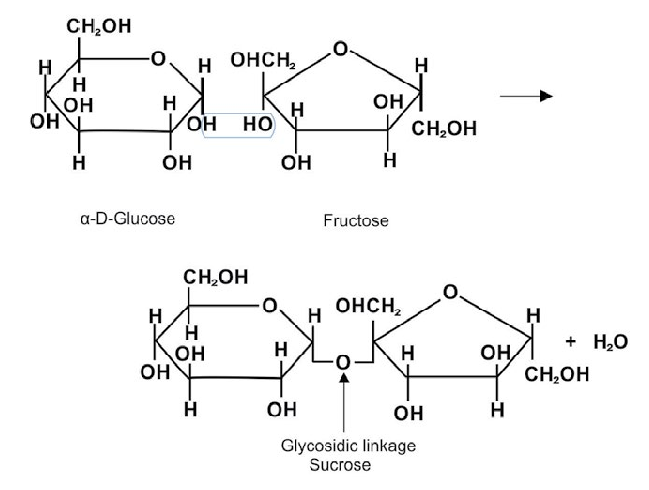

**HO**

**HO**

Conversely, hydrolysis of an oligosaccharide by water in the presence of an acid or by enzymes yields two or more monosaccharide units.

Among the most common disaccharides are sucrose, lactose and maltose. Of these, sucrose occurs in sugar cane, sugar beet, pineapple, apricot, mango, almond, coffee and honey. Lactose (milk sugar) occurs in the milk of all animals. It does not occur in plants.

Trisaccharides, which yield three monosaccharide molecules on hydrolysis, have molecular formula, C18H32O16, for example, raffinose. In general, the mono-saccharides and oligosaccharides are crystalline solids soluble in water and sweet to taste. They are collectively known as ‘sugars’.

##### 3. Polysaccharides

The polysaccharides are carbohydrates of high molecular mass which yield many monosaccharide molecules on hydrolysis. Examples are, starch and cellulose, both of which have molecular formula, (C6H10O5)n.The polysaccharides are amorphous solids, insoluble in water and tasteless and are called ‘non-sugars’. Polysaccharides perform two principal functions in animals and plants. They are used as energy storage compounds and for building structural elements of cells. Plants store glucose as starch and animals store glucose in the form of a highly branched polymer known as glycogen. Glycogen is stored in the liver and muscles. **i) Starch**

Starch is the most important source of carbohydrates in human diet. The chief commercial sources of starch are wheat, rice, maize, potatoes and barley. Starch is a polymer of a-D-glucose.

Starch is not a pure compound. It is a mixture of two polysaccharides, amylose and amylopectin which can be separated from one another. Amylose is soluble in water and gives a deep blue colour with iodine while amylopectin is insoluble and gives no colour. Natural starch consists of 10 to 20% amylose and 80 to 90% amylopectin. It is used in coating and sizing of paper to improve the writing qualities. It is also used in laundering and in the manufacture of glucose and ethyl alcohol.

13

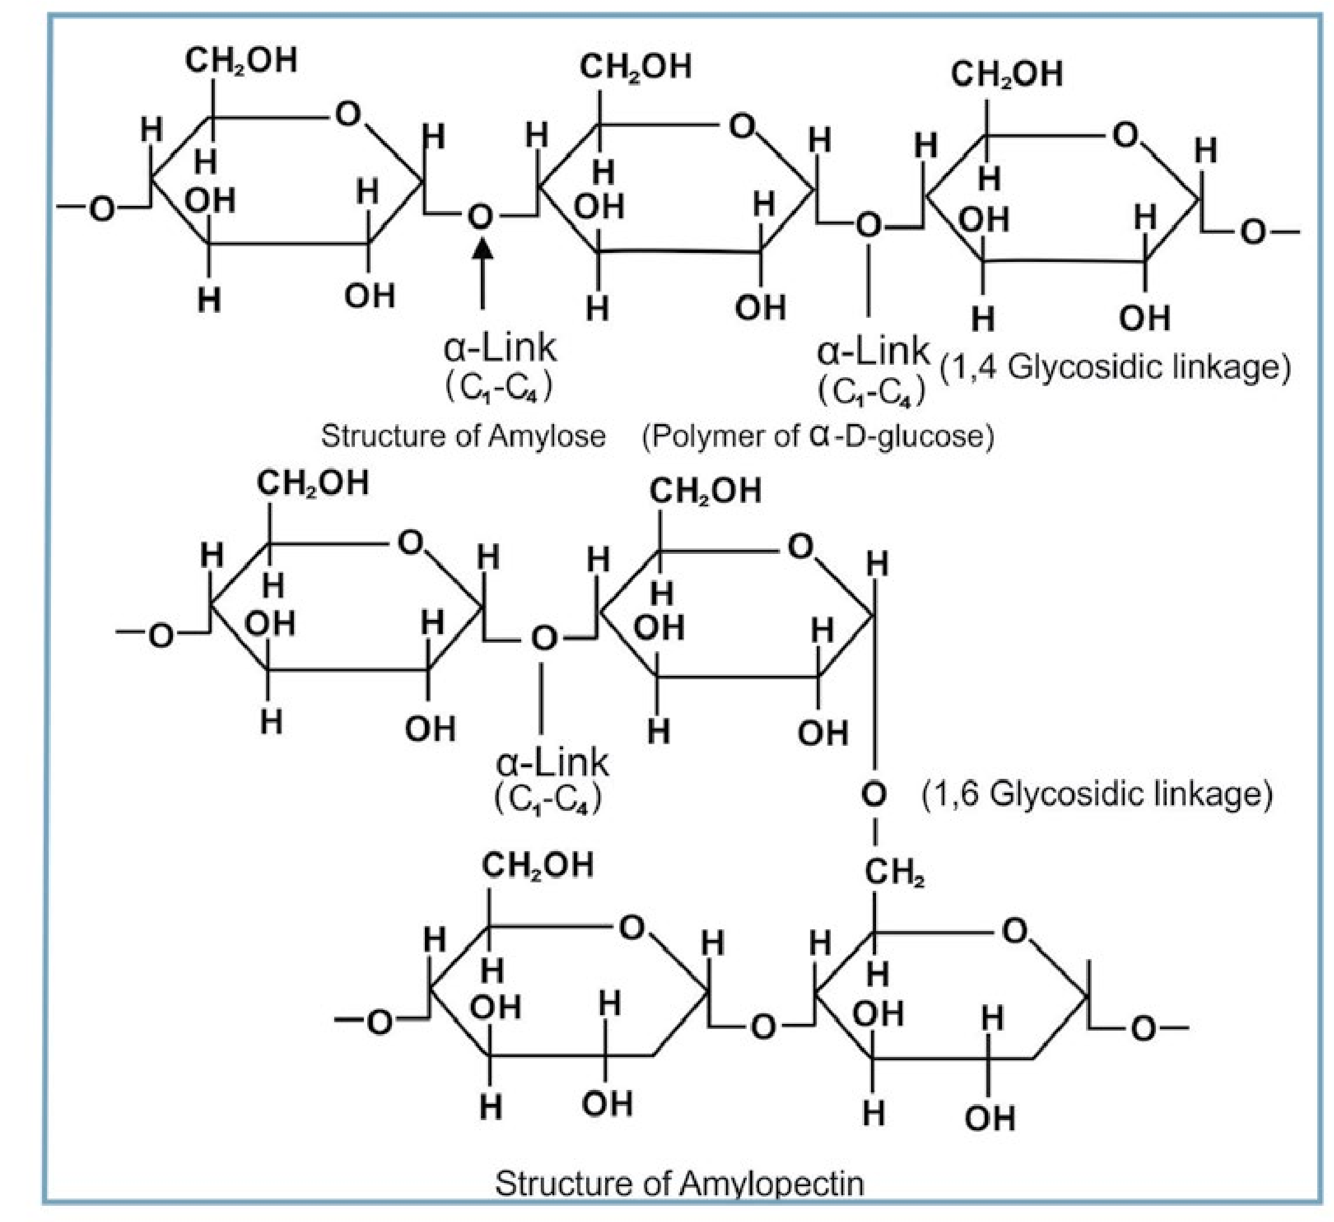

##### ii) Cellulose

By far, the most abundant structural polysaccharide is cellulose. Some 100 billion tons of cellulose are produced each year by plants. For example, cotton is 99% cellulose and the woody parts of trees are generally more than 50% cellulose. It is a polymer of β-D-glucose. It is present mainly in the plant kindom but also occurs in some marine animals. It is an unbranched polymer consisting of a large number (up to 2500) of glucose residues joined to each other through β -1—>4 linkages.

14

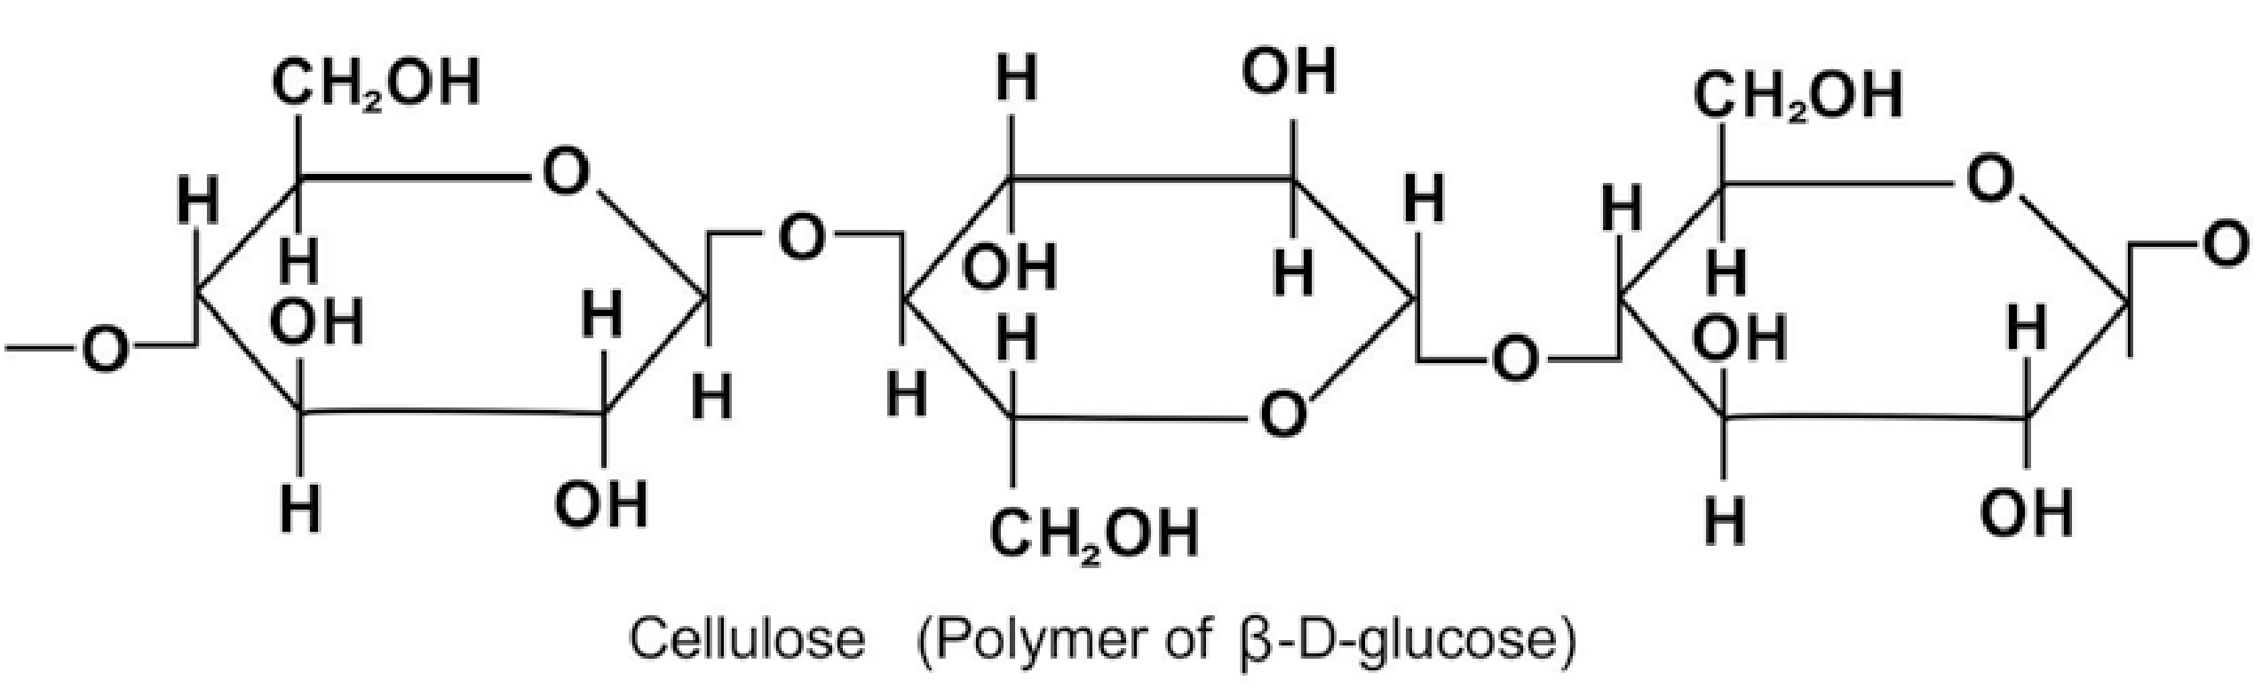

##### iii) Glycogen

It occurs mainly in the liver and muscles where it represents the main storage polysaccharide in the same way as starch functions in plant cells. Glycogen is therefore also called ‘animal starch’. Its structure closely resembles with that of amylopectin having 1 4 and 1 6 glycosidic linkages.   Human glycogen is a much more branched molecule than amylopectin.

On hydrolysis it yields glucose units.

#### 14.6.3 Proteins

Proteins are extremely complicated molecules of living things. They are the nitrogeneous compounds made up of a variable number of amino acids. The human body probably contains at least 10,000 different kinds of proteins. The name protein is derived from the Greek word proteios meaning of prime importance.

Proteins are present in all living organisms and without proteins life would not be possible. They are present in muscles, skin, hair and other tissues that make up the bulk of the body’s non-bony structure.

All proteins contain the elements carbon, hydrogen, oxygen and nitrogen. They may also contain phosphorus and traces of other elements like iron, copper, iodine, manganese, sulphur and zinc. Proteins are very high molecular weight macromolecules.All proteins yield amino acids upon complete hydrolysis.

Thus proteins may be defined as the high molecular weight organic materials, which upon complete hydrolysis, yield amino acids.

15

##### 14.6.4 Classfication of Proteins

Based on the physico-chemical properties, proteins may be classified into three types.

1. Simple protiens 2. Compound or Conjugated proteins

3. Derived proteins

##### 1. Simple Proteins

These proteins on hydrolysis yield only amino acids or their derivatives. For example, albumins, globulins, legumin, collagen, etc. Globulins are insoluble in water but soluble in dilute salt solutions. They are found in animals, e.g; lactoglobulin is found in muscles and also in plants. Legumin and collagen proteins are present in the connective tissues throughout the body . They are the most abundant proteins in the animal kingdom forming some

25 to 35% of body protein.

##### 2. Compound or Conjugated Proteins

In these molecules the protein is attached or conjugated to some non- protein groups which are called prosthetic groups. For example; phospho-proteins are conjugated with phosphoric acid, lipoproteins are conjugated with lipid substances like lecithin, cholesterol and fatty acids. **3. Derived Proteins**

This class of protein includes substances which are derived form simple and conjugated proteins.For example, proteoses enzymes, peptones, oligopeptides, polypeptides, etc.

Based on their functions, proteins may also be classified as regulatory or hormonal proteins, structural proteins, transport proteins, genetic proteins, etc.

###### 14.6.5 Structure of Proteins

The majority of proteins are compact, highly convoluted molecules with the position of each atom relative to the others determined with great precision. To describe the structure of a protein in an organism it is necessary to specify the three- dimensional shape that the polypeptide chain assumes. Proteins assume at least three levels of structural organization.

16

(i) Primary structure (ii) Secondary structure

(iii) Tertiary structures

Some proteins also possesses a fourth structure called the quaternary structure.

The sequence of the amino acids combined in a peptide chain is referred to as the primary structure.

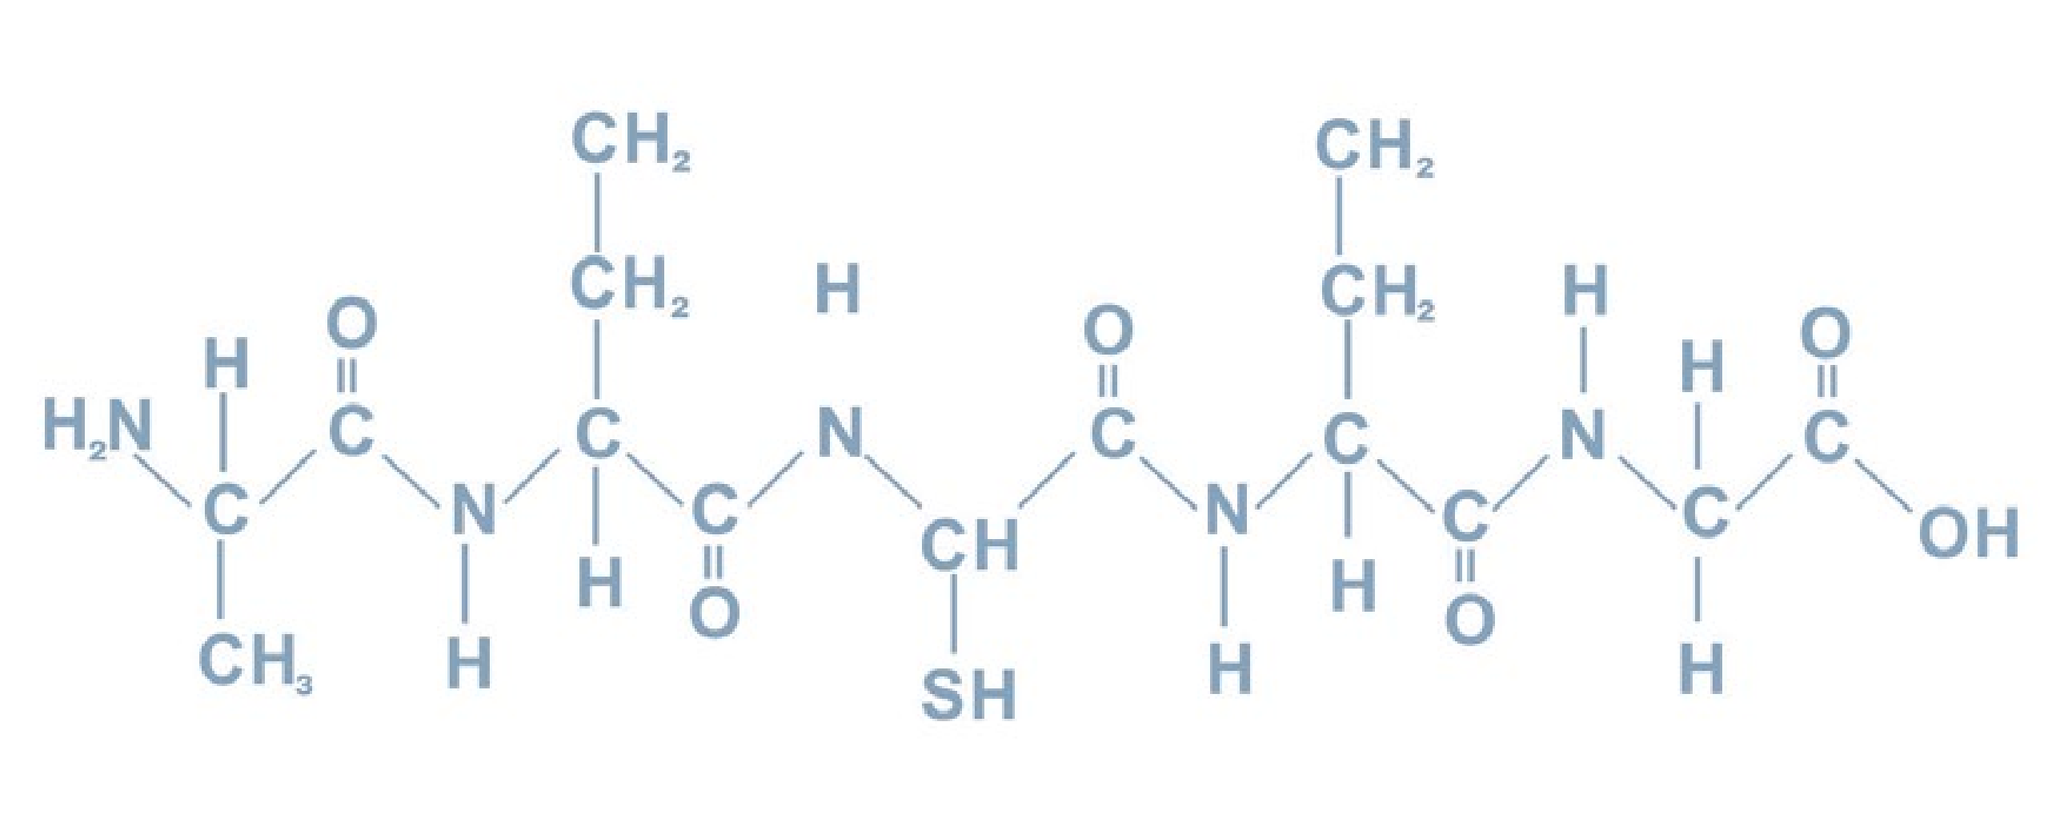

The secondary structure of a protein is a regular coiling or zigzagging of polypeptide chains caused by hydrogen bonding between NH and C = 0 groups of amino acids near each other in the chains. The three dimensional twisting and folding of the polypeptide chain results in the tertiary structure of proteins.

#### 14.6.6 Denaturation of Proteins

The structure of proteins can be disrupted easily by heat, change in pH and under strongly oxidizing or reducing conditions. Under such conditions the proteins undergo denaturation. The most familiar example of denaturation is the change that takes place in albumin, the principal component of egg white, when it is cooked. In this particular case the change is irreversible.

17

##### 14.6.7 Importance of Proteins

1. Proteins take an essential part in the formation of protoplasm which is the essence of all forms of life.
2. Nucleoproteins which are complexes of proteins with nucleic acids serve as carriers of heredity from one generation to the other.
3. Enzymes which are biological catalysts are protein in nature. Without them life is not possible.
4. Many proteins have specialized functions. Haemoglobin acts as a carrier of O2. Some proteins act as hormones which have regulatory functions, for example; insulin, thyroxine etc.

Industrially proteins have great importance. We are familiar with the use of leather made by tanning of hides. This is essentially a precipitation of the proteins with tannic acid. Gelatin is obtained by heating bones, skin and tendons in water. It is used in bakery goods. Caesein is another protein used in the manufacture of buttons and buckles.

#### 14.6.8 Lipids

Lipids (Greek, lipos means fat) are naturally occurring organic compounds of animals and plants origin which are soluble in organic solvents and belong to a very heterogeneous group of substances.

Lipids have the following characteristics:

1. They are insoluble in water and soluble in non-polar solvents e.g. ether, chloroform and benzene, etc.
2. Their primary building blocks are fatty acids, glycerol and sterols.
3. They are utilized by the living organisms.

18

Fats and oils are the most important lipids found in nature. They are one of the three major “food factors” needed for human body, the other two being proteins and carbohydrates. Fats and oils are widely distributed in various type of foods and are of great nutritional value. Not only the edible fats and oils occupy a place of pride in human diet but they also find use as raw materials for the manufacture of soaps and detergents, paints, varnishes, polishes, cosmetics, printing inks and pharmaceuticals.

##### 14.6.9 Sources of Fats and Oils

Fats and oils come from a variety of natural sources like animals, plants and marine organisms. Animal fats are located particularly in adipose tissue cells. Butter and ghee are a special type of animal fats which are made form milk. Vegetable oils are chiefly present in seeds and nuts of plants. Marine oils are obtained form sea animals like salmons and whales etc. **14.6.10 Structure and Composition of Fats and Oils**

Animal and vegetable fats and oils have similar chemical structures. They are triesters formed from glycerol and long chain acids called fatty acids.

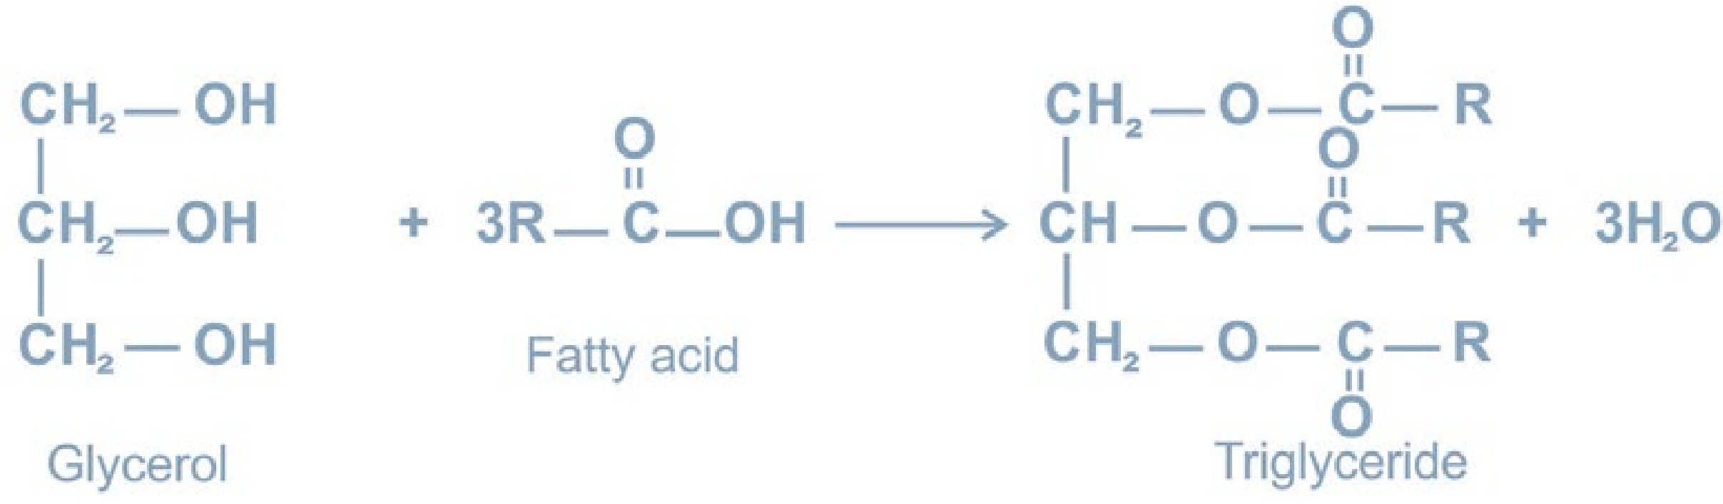

A triester of glycerol is called a triglyceride or glyceride.The degree of unsaturation of the constituent fatty acid determines whether a triglyceride will be a solid or a liquid. The glycerides in which long- chain saturated acid components predominate tend to be solid or semisolid and are termed as fats.On the other hand, oils are glycerol esters which contain higher proportion of unsaturated fatty acid components.

19

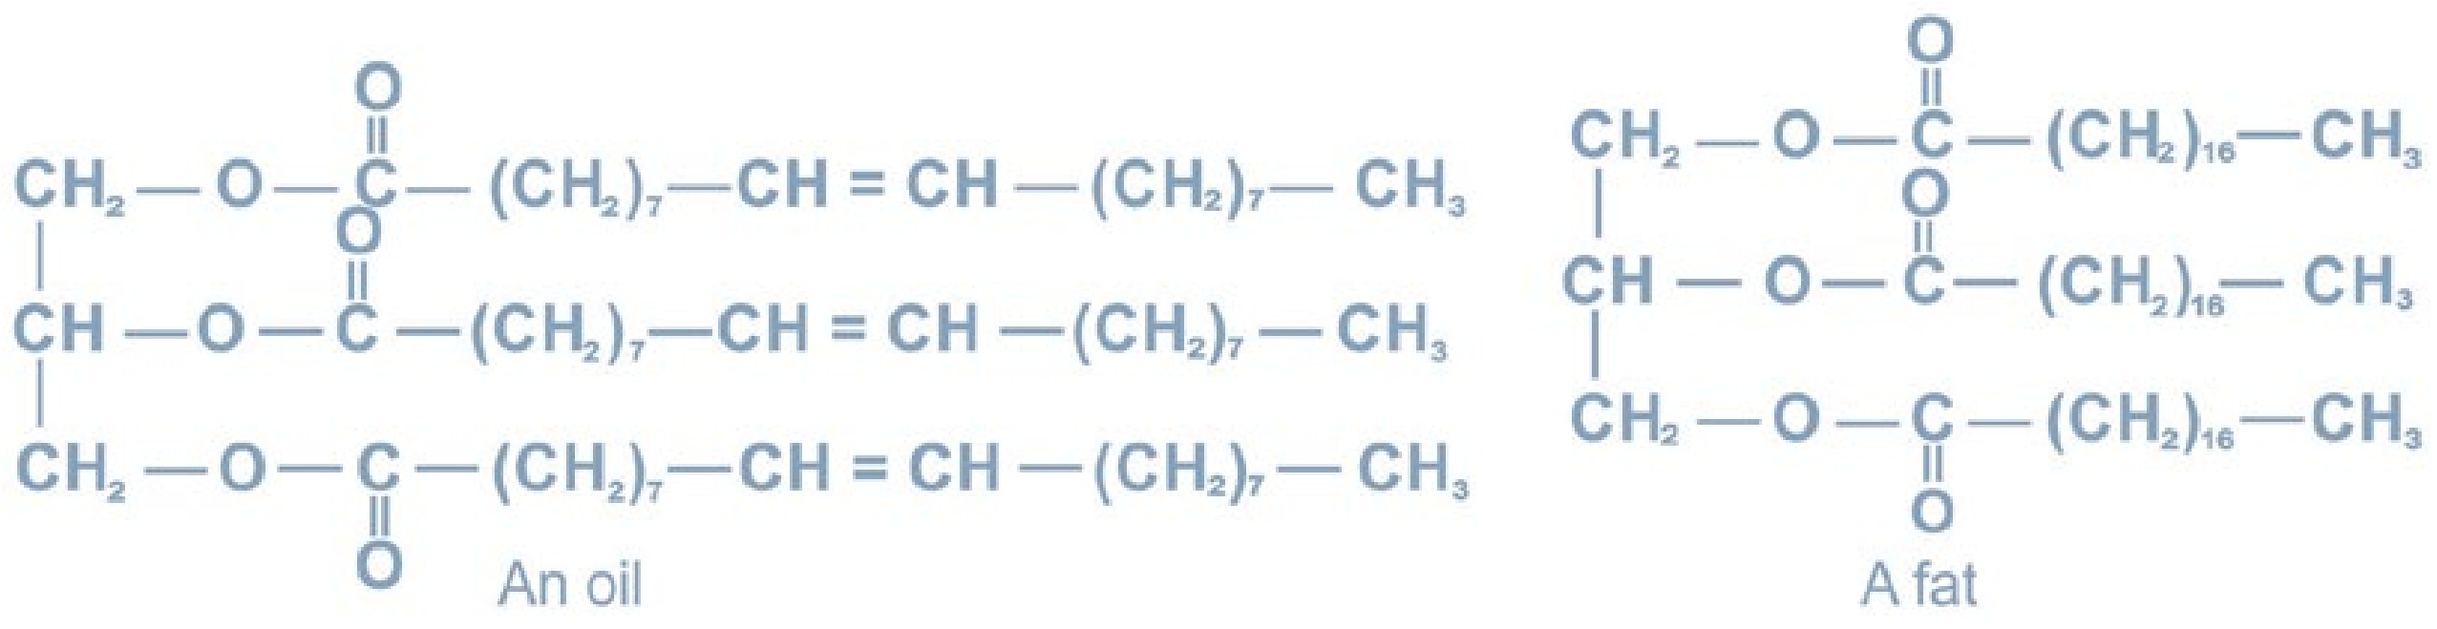

The melting points of mixed glycerides would depend on the extent of unsaturated fatty acid components in the molecule. The poly unsaturated glycerides therefore have very low meting points and are liquids (oils). Chemically common oils and fats are the mixture of saturated and unsaturated triglycerides, present in various ratios.

**14.6.11 Classification**

Lipids are classified as:

**1. Simple Lipids**

These are esters of fatty acids with glycerol. For example, common fats and oils.

##### 2. Compound Lipids

These contain radicals in addition to fatty acids and alcohol and include glycerol phospholipids, sphingolipids, lipoproteins and lipopolysaccharides.

##### 3. Derived or Associated Lipids

They are the hydrolytic products of the above mentioned compounds. Sterols, vitamin D and terpenes belong to this class of lipids.

###### 14.6.12 Physical Properties

1. Oils and fats may either be liquid or non-crystalline solids at room temperature.
2. When pure they are colourless, odourless and tasteless.
3. They are insoluble in water and readily soluble in organic solvents like diethyl ether, acetone, carbon tetrachloride and carbon disulphide.
4. They readily form emulsions when agitated with H20 in the presence of soap or other emulsifiers.
5. They are poor conductor of heat and electricity and therefore serve as excellent insulator for the animal body.

20

##### 14.6.13 Chemical Properties

###### 1. Hydrolysis

Triglycerides are easily hydrolyzed by enzymes called lipases to fatty acids and glycerol.

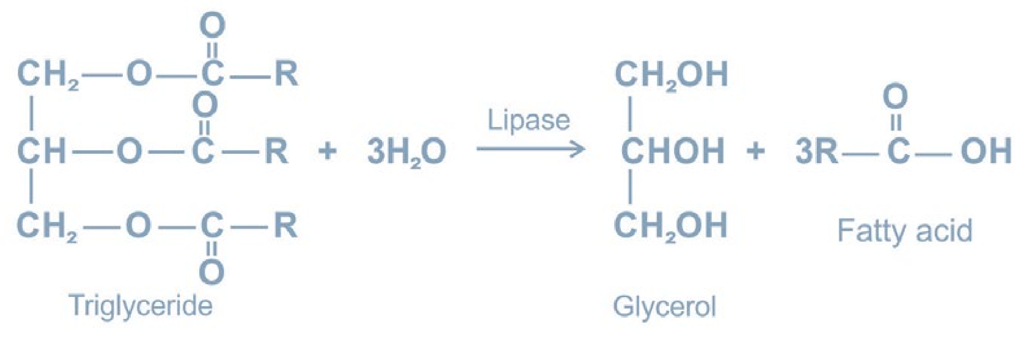

###### 2. Saponification

It is the hydrolysis of a fat or an oil with an alkali to form soap (salt of fatty acid) and glycerol.

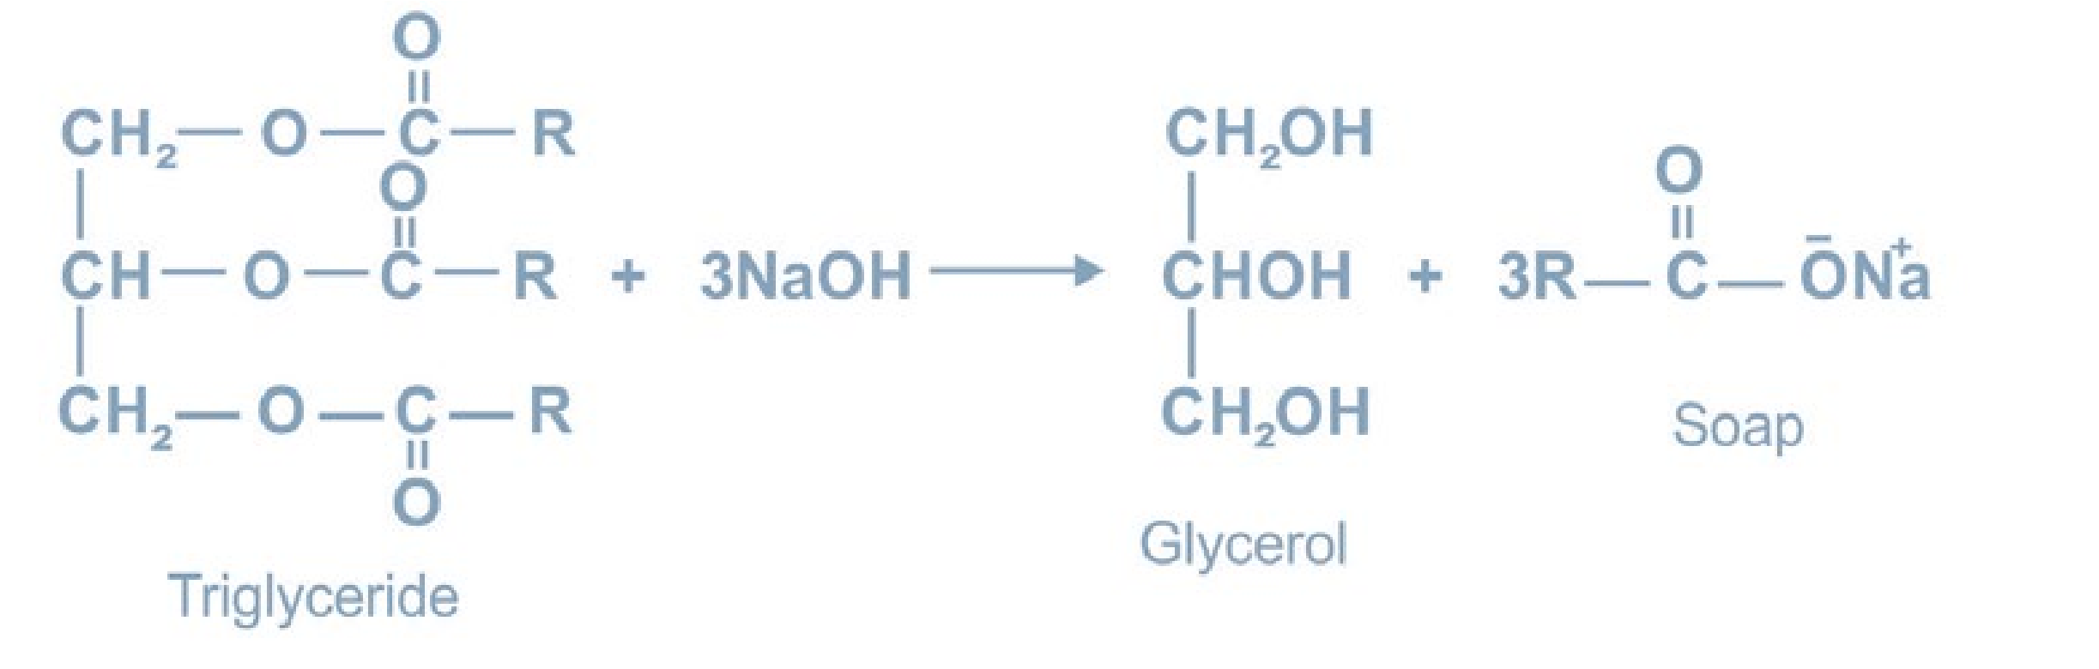

3. Hardening of Oils

Unsaturated glycerides react with hydrogen in the presence of a metal catalyst to give saturated glycerides. The result is the conversion of a liquid glyceride (an oil) into a semi-solid glyceride (a fat).

21

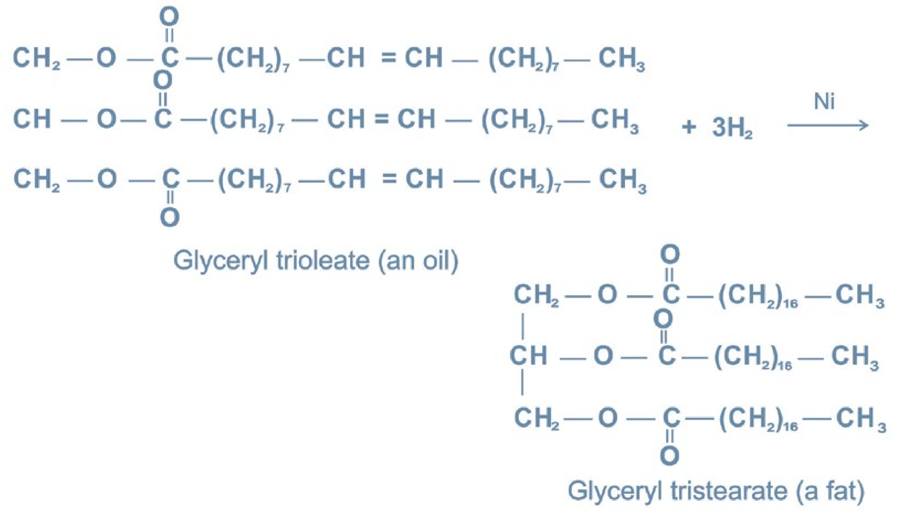

This

reaction

is

used

commercially

to

harden

vegetable

oils

for

the production of vegetable ghee or margarine. Hardened oils are also extensively used for making soaps and candles.

##### 14.6.14 Saponification Number

It is defined as the number of milligrams of potassium hydroxide or sodium hydroxide required to saponify one gram of the fat or oil. For example, one mole of glycerol tripalmitate (mol. wt = 807) requires 168,000 mg of KOH for saponification. Therefore, one gram of fat will require 168000/807 mg of KOH. Hence the saponification number of glycerol tripalmitate is 208.

##### 14.6.15 Rancidity of Fats or Oils

Fats or oils are liable to spoilage and give off an odour known as rancidity. It is mainly caused by the hydrolytic or oxidative reactions which release foul smelling aldelydes and fatty acids. Oils from sea animals which contain a relatively high proportion of unsaturated acid chains deteriorate rapidly.

22

###### 14.6.16 Iodine Number

The extent of unsaturation in a fat or an oil is expressed in terms of its iodine number. It is defined as the number of grams of iodine which will add to 100 grams of a fat or an oil The value of iodine number depends on the number of double bonds present in the acid component of the glycerides. The glycerides with no double bonds have zero iodine number.

###### 14.6.17 Acid Number

The acid number of a fat or an oil tells the amount of free fatty acids present in it. It is expressed as the number of milligrams of potassium hydroxide required to neutralize one gram of fat.

###### 14.6.18 Steroids

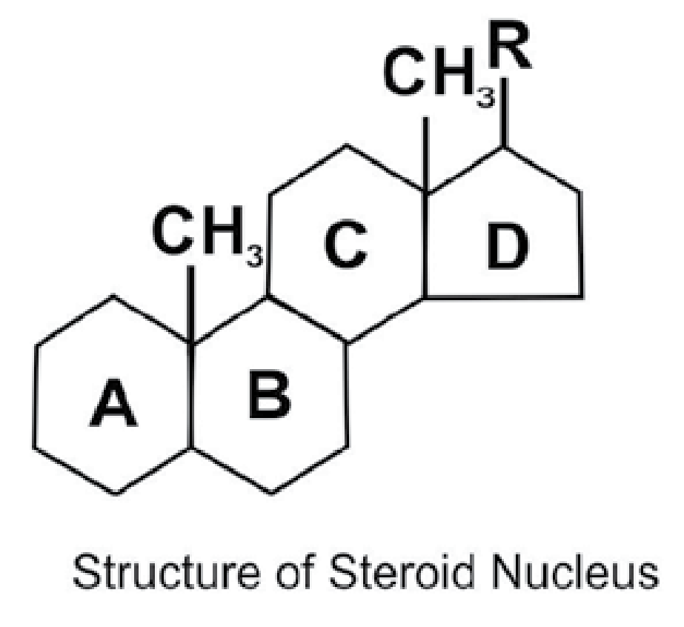Steroids are naturally occurring lipids. Their parent nucleus has perhydrocyclopentanophenanthrene component which consists of three six- membered rings (A, B and C) and one five-membered ring (D). These rings are joined or fused to each other and have a total of 17-C atoms Very small variations in the bonding of atoms in the ring and in the groups attached to them give rise to compounds that are remarkably diverse in their biological functions. Some of the natural occurring compounds belonging to steroids are cholesterol, ergosterol, male and female sex hormones and the hormones of the adrenal cortex.

###### 1. Cholesterol

It is the most abundant animal sterol and occurs in all animal tissues but only in a few higher plants. Cholesterol is present both in the free as well as esterified form in the blood, animal tissues, egg, yolk, various oils and fats and nerve tissues. Its increased quantities in blood makes plaque like deposits in the arteries causing blood pressure and other heart diseases.

23

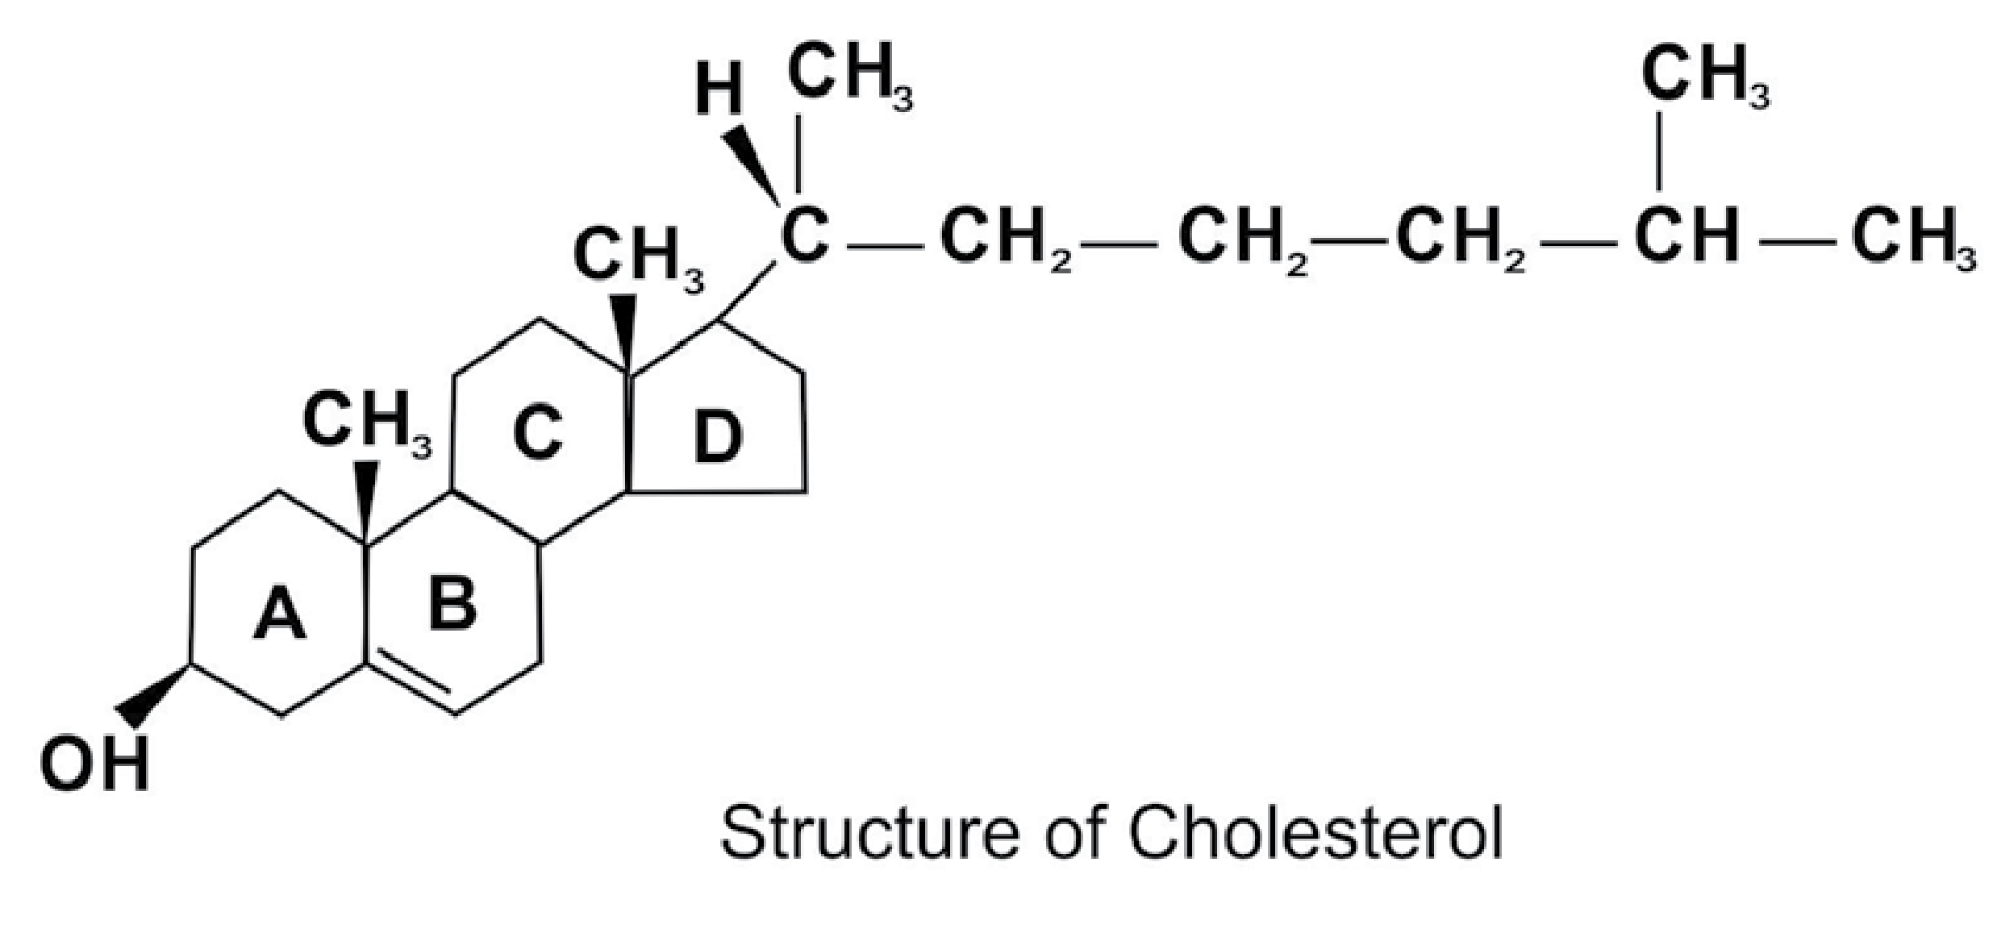

###### 2. Ergosterol

It is the sterol of fungi and yeasts. When irradiated with ultraviolet rays, it is converted into ergocalciferol or vitamin D2.

###### 3. Phospholipids

Phospholipids are molecules of enormous biological importance. In the compounds, two of the hydroxyl groups are esterified with fatty acids and third forms a link with phosphoric acid or a derivative of phosphoric acid.

##### 14.6.19 Importance of lipids

1. They are good source of energy and make the food more palatable.
2. They exert an insulating effect on the nervous tissues.
3. They are good energy reservoirs in the body.
4. Lipids are an integral part of cell protoplasm and cell membranes.
5. Some lipids act as precursors of very important physiological compounds. For example, cholesterol is the precursor of steroid hormones.

24

###### 14.6.20 Enzymes

Enzymes can be defined as the reaction catalysts of biological systems produced by living cells and are capable of catalyzing chemical reactions. Typically enzymes are macromolecules with molecular masses ranging into millions. Two remarkable properties of enzymes are their extraordinary specificity each enzyme catalyzes only one reaction or one group of closely related reactions and their amazing efficiency they may speed up reactions by factors of upto 1020. Each enzyme molecule possesses a region known as the active site and the substrate binds itself with this active site.

Enzymes are either pure proteins or contain proteins as essential components and in addition require non-protein components which are also essential for their activity.

The protein component of the enzyme is called apoenzyme and the non-protein component is called the co-factor or co-enzyme.The co-factors include inorganic ions and complex organic or metallo-organic molecules. Important inorganic co-factors alongwith their respective enzymes include Fe2+(chrome oxidase) Zn2+(carbonic anhydrase) and Mg2+(glucose 6- phosphatase), etc. Many enzymes contain vitamins as their co-factors, for example; nicotinamide adenine dinucleotide contains nicotinamide vitamin and thiamine pyrophosphatase contains vitamin B1.

While naming the enzymes, suffix-“ase” is added to the name of the substrate on which the enzyme acts, for example, urease, sucrase, cellulase are the enzymes, which act upon the substrates urea, sucrose and cellulose respectively.

###### 14.6.21 Classification of Enzyme

The commission on enzyme, appointed by the International Union of Bio-Chemistry (IUB) classified enzymes into six main types.

25

###### 1. Oxidoreductases

These enzymes catalyze oxidation-reduction reactions. Common examples are oxidase, dehydrogenase and peroxydase.

###### 2. Transferases

These enzymes bring about an exchange of functional group such as phosphate or acyl between two compounds,For example; phospho-transferases, etc.

###### 3. Hydrolases

These enzymes catalyze hydrolysis.They include proteases called protolytic enzymes.

###### 4. Lyases

These enzymes catalyze the addition of ammonia, water or carbon dioxide to double bonds or removal of these to form double bonds, for example phospho-glyceromutases.

###### 5. Isomerases

These enzymes catalyze the transfer of groups within molecules to yield isomeric forms of the substrate . An example is the conversion of fumaric acid to maleic acid in’ the presence of fumarase enzyme.

###### 6. Ligases

These enzymes link two molecules together through the breaking of high energy bonds, for example; acetyl S COH, a carboxylase and succinic thiokinase.

**14.6.22 Properties of Enzymes**

###### 1. Specificity

Enzymes are specific in their action which means that an enzyme will act on only one substrate or a group of closely related substrates. For example, hexokinase catalyses the conversion of hexoses like glucose, fructose and mannose to their 6-phosphate derivatives but glucokinase is specific for glucose only.

26

2. Protein Nature

Enzymes with few exceptions are protein in nature. They are produced by living cells but act in vivo as well as in vitro.

3. The Direction of Enzym e Reactions

Most enzymatic reactions are reversible i.e. the same enzyme can catalyze reactions in both directions.

4. Isoenzymes

These are the enzymes from the same organisms which catalyze the same reaction but are chemically and physically distinct from each other.

**14.6.23 Factors Affecting Enzyme Activity**

1. Enzyme Concentration

The rate of an enzymatic reaction is directly proportional to the concentration of the substrate. The rate of reaction is also directly proportional to the square root of the concentration of enzyme. It means that the rate of reaction also increases with the increasing concentration of enzyme

2. Temperature

The enzymatic reaction occurs best at or around 37°C which is the average normalbody temperature. The rate of chemical reactions is increased by a rise in temperature but this is true only over a limited range of temperature. The enzymes usually destroy at high temperature. The activity of enzymes is reduced at low temperature. The temperature at which an enzyme reaction occurs the fastest, is called its optimum temperature.

27

###### 3. Effect of pH

Just like temperature, there is also an optimum pH at which an enzyme will catalyze the reaction at the maximum rate. For example, the optimum pH of salivary amylase is 6.4 to 6.9.

4. Other Substances

The enzyme action is also increased or decreased in the presence of some other substances such as co-enzymes, activators and inhibitors. For example, some enzymes consist of simple proteins only such as insulin. Most of the enzymes are, however, the combination of a coenzyme and an apo-enzyme. Activators are the inorganic substances which increase the enzyme activity. For example; Mg2+ and Zn2+ ions are the activators of phosphatase and carbonic anhydrase enzymes respectively. Inhibitors are the substances which reduce the enzyme activity.

5. Radiation

Generally enzymes are readily inactivated by exposure to ultraviolet light, beta rays, gamma rays and X-rays.

14.6.24 Importance of Enzymes

Enzymes are of great biological importance and are of great help in the diagnosis of certain diseases. Some examples are, alkaline phosphatase is raised in rickets and obstructive jaundice, lactic dehydrogenase or LDH-1 is raised in heart diseases. Many enzymes have proved very useful as drugs. For example; thrombin is used locally to stop bleeding. Many enzymes are used for cancer treatment, for example, L-asparaginase has proved very useful in the treatment of blood cancer in children.

14.6.25 Nucleic Acids

Nucleic acids were first demonstrated in the nuclei of pus cells in 1868 and in sperm heads in 1872 by Friedrik Miescher. They are present in every living cell as well as in viruses and have been found to be the essential components of the genes. They contain in their structure the blue-prints for the normal growth and development of each and every living organism.

28

The nucleic acids are responsible for the two fundamental functions which are common to all living organisms, these are (a) their ability to reproduce, store and transmit genetic information and (b) to undergo mutation.

Two types of nucleic acids have been discovered, deoxyribonucleic acid (DNA) and ribonucleic acid (RNA). In the body nucleic acids occur as part of the conjugated proteins called nucleoproteins. The nucleic acids direct the synthesis of proteins. Cancer research involves an extensive study of nucleic acids.

14.6.26 Components of Nucleic Acids

Both DNA and RNA are formed by joining together a large number of nucleotide units or mononucleotides units, each of which is a nitrogenous base sugar phosphoric acid complex.

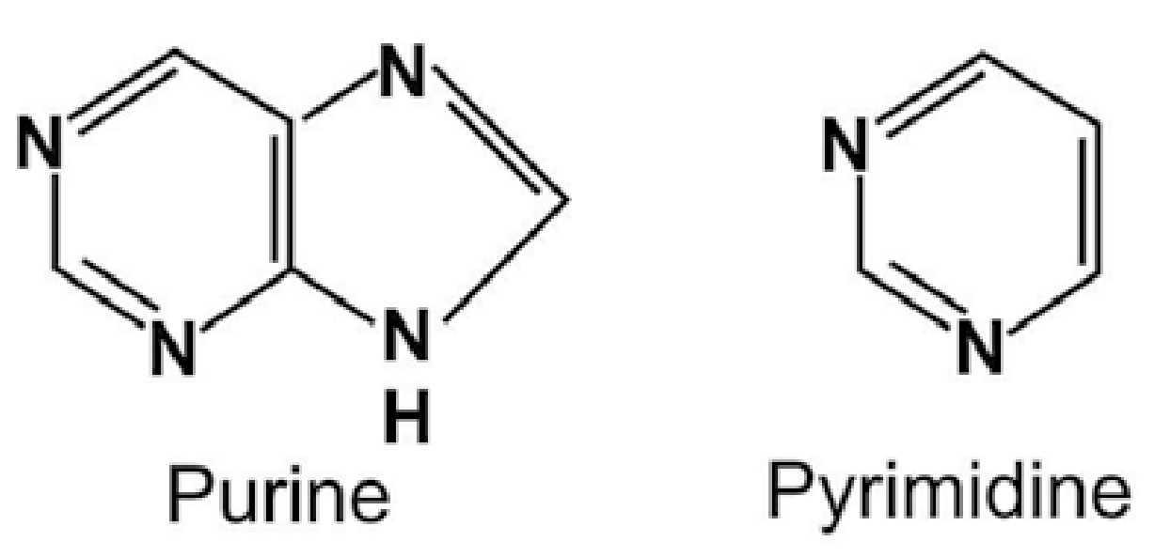

Nitrogenous bases are either purine or pyrimidine derivatives. Purines include adenine and guanine whereas pyrimidines include, cytosine, uracil and thymine. A nucleoside is a combination of nitrogenous base (purine or a pyramidine) with a sugar (ribo or deoxyribose). Depending upon the presence of ribo or a deoxyribo, nucleoside can either be a ribonucleoside or deoxyribonucleoside. Dexoyribonucleic acid (DNA) carries the genetic information and ribonucleic acid (RNA) is involved in putting this information to work in the cell. They differ in three ways.

1. The sugar in RNA is ribose while the sugar in DNA is 2-deoxyribose.
2. Four different bases are found in DNA cytosine (C), thymine (T), adenine (A) and guanine (G). In RNA, .thy mine does not occur and its place is taken by uracil (U).
3. DNA is nearly always double stranded, while RNA is usually single stranded.

29

The key to the ability of DNA to preserve genetic information and to pass it on from generation to generation is its double-stranded structure, first deducted by James Watson and Francis Crick in 1953. This was the discovery that initiated the field of molecular biology. Watson and Crick noticed that the double stranded structure provides a mechanism whereby the genetic information can be duplicated. This process is called replication. The synthesis of a polypeptide (protein) involves a series of events which occur in accordance with the information contained in the DNA.

### KEY POINTS

1. Macromolecules are large molecules built up from small units called monomers.
2. The organic macromolecules are biological and non- biological in nature.3. Biological macromolecules are called life molecules and non-biological are man made synthetic polymers.
3. The polymer chains may be linear, branched or cross-linked.
4. A thermoplastic polymer is the one which can be softened and hardened by heating and cooling respectively.
5. A thermosetting polymer is one which becomes permanently hard on heating.
6. The polymerization process involves addition and condensation reactions.
7. The formation of polyethene is an example of addition polymerization.
8. Nylon, a polyamide and terylene, a polyester, are examples of condens -ation polymers.
9. Carbohydrates, proteins, fats, and nuclei acids are naturalmacromolecules.11. Carbohydrates are the most abundant biomolecules on earth.They are classified into monosaccharides, oligosaccharides and polysaccharides. 12. Proteins are the essential components of all living organisms. They are the polymers of amino acids.
10. Lipids are naturally occuring organic compounds of animal and plant origin and they are soluble in organic solvents. Fats and oils are the most important lipids found in nature.
11. Enzymes are proteins that catalyze chemical reactions in living organisms.

They are very specific in their action.

30

### EXERCISE

**Q. 1 Fill in the blanks**

1. Macromolecules are built up from small units called______
2. Nylon is a polyamide and terylene is a _________
3. Nylon is prepared by the reaction of _________ and hexamethylenediamine.
4. Based on their thermal properties, plastics are divided into _________ main classes.
5. Polyvinyl chloride is a ________ plastic.
6. Glucose is stored as________ in the liver.
7. Glucose and fructose are water_________ carbohydrates.
8. Protein after digestion changes to _______
9. Purine and pyrimidine are_________ of nucleic acids.
10. Addit ion of a plasticizer _________ the flexibility of the polymer.

**Q. 2 Indicate True or False.**

1. Nylon 6,6 and terylene are condensation polymers.
2. The disposal of plastics does not cause any pollution problem.
3. Fructose is a polysaccharide carbohydrate.
4. Human beings get no food nutrient from cellulose.
5. The most abundant and the most important steroid in the human body is vitamin D.
6. Enzymes are the compounds containing C, H and O only.
7. The degree of unsaturation of fats is measured by their iodine number.
8. Activity of an enzyme varies with temperature and pH.
9. Nucleic acids are biological catalysts.
10. The nucleic acids are responsible for protein synthesis in the human body.

**Q. 3. Multiple choice questions. Encircle the correct answer.**

(i) In which of these processes are small organic molecules made into

macromolecules

1. the cracking of petroleum fractions
2. the fractional distillation of crude oil
3. the polymerization of ethene
4. the hydrolysis of proteins

31

(ii) Which of these polymers is an addition polymer?

(a) nylon-6,6 (b) polystyrene (c) terylene (d) epoxy resin

(iii) Which of these polymers is a synthetic polymer?

(a) animal fat (b) starch (c) cellulose (d) polyester

(iv) Plastics are a pollution problem because many plastics

1. are made from petroleum
2. are very inflammable
3. burn to produce toxic fumes
4. decompose to produce toxic products

(v) The fibre which is made from acrylonitrile as monomer:

(a) PVC (b) rayon fibre (c) acrylic fibre (d) polyester fibre

(vi) A polymeric substance that is formed in the liquid state and then hardened to a rigid solid is called a

(a) fibre (b) plastic (c) varnish (d) polyamide resin

(vii) Vegetable oils are

(a) unsaturated fatty acids (b)glycerides of unsaturated fatty acids (c) glycerides of saturated fatty acids (d)essential oils obtained from plants

(viii) Which one of the following elements is not present in all proteins?

(a) carbon (b) hydrogen (c) nitrogen (d) sulphur

(ix) Which one o f the following nitrogeneous bases is not present in RNA

(a) cytosine (b) adenine (c) thiamine (d) uracil

(x) Which one of the following enzymes brings about the hydrolysis of fats?

(a) urease (b)maltase (c) zymase (d) lipase

32

(xi) The reaction between fat and NaOH is called

(a) esterification (b) hydrogenolysis (c) fermentation (d) saponification

(xii) Which one of the following statements about glucose and sucrose is incorrect?

(a) both are soluble in water (b) both are naturally occurring (c) both are carbohydrates (d) both are disaccharides

**Q. 4** Explain the following terms:

(a) Addition polymer (b) Condensation polymer

(c) Thermoplastic (d) Thermosetting plastic

Q. 5 Write notes on

(a) Polyester resins (b) Polyamide resins (c) Epoxy resins

**Q. 6** What is the repeating unit in each of the following polymers?

(a) polystyrene (b) nylon 6,6 (c) teflon (d) orlon

**Q. 7** What are carbohydrates and how are they classified?

**Q. 8** Point out one difference between the compounds in each of the following pairs.

1. Glucose and fructose
2. Sucrose and maltose(c) Cellulose and starch

**Q. 9** What are lipids? In what way fats and oils are different?

**Q. 10** Define saponification number and iodine number. Discuss the term rancidity.

1. **11** What is the difference between a glycoside linkage and a peptide linkage?

**Q.12** What is the chemical nature of enzymes? Discuss the classification of enzymes.

**Q. 13** What are nucleic acids? Write down the role of DNA and RNA in life.

33